Institute for Strategic Research and Education – ISIE (Skopje)
Institute for Development Research and Alternatives - IDRA (Tirana)
Centre for Free Elections and Democracy – CESID (Belgrade)

STUDY ON CORRUPTION PERCEPTIONS AND PREVENTION
IN THE HIGHER EDUCATION OF ALBANIA, NORTH MACEDONIA AND SERBIA

Skopje, 2023

Title of the original: STUDY ON CORRUPTION PERCEPTIONS AND PREVENTION IN THE HIGHER EDUCATION OF ALBANIA, NORTH MACEDONIA AND SERBIA

Institute for Strategic Research and Education
For the publisher: Mišo Dokmanović
Authors: Rozarta Dodaj, Miloš Hrnjaz, Ivana Shumanovska Spasovska,
Editor: Mišo Dokmanović
Editorial Board: Darko Spasevski (ISIE), Blerta Kalavace (IDRA), Jelena Jeremic (CESID)
Published in electronic form.

Introduction

The region of Western Balkans including Albania, North Macedonia and Serbia for a confined period of time have been dealing with the issue of corruption. A number of initiatives have been implemented in the last decade yet without a more focused approach to the specific sector of higher education (HE). Additionally, in the latest 2022 EU progress reports, all three countries have been criticized for the existing mechanisms for reporting and prevention of corruption. The conclusion for all three countries in the segment of Chapter 23 has stated that some level of preparation/is moderately prepared in implementing the EU acquis and European standards in the area of the judiciary and fundamental rights. According to the Report, Albania has achieved good progress in the last year; North Macedonia – some progress and Serbia – limited progress.
Having this in mind, in the period from 2023-2024 the Institute for Strategic Research and Education – ISIE (Skopje) in cooperation with Institute for Development Research and Alternatives - IDRA (Tirana) and Centre for Free Elections and Democracy – CESID (Belgrade) is implementing the regional project “Corruption Free Universities in Albania, North Macedonia and Serbia”. The project is aimed at strengthening capacities of universities, student organizations and students for corruption prevention at the universities in the targeted three countries. Through diverse set of activities including preparation Joint Report on corruption perception, organization of roundtables, capacity building seminars, summer school and development of virtual assistant (chatbot) digital software, the project will boost a corruption prevention enabling environment in the field of higher education in the targeted countries of the Western Balkans.
This Joint Report on corruption perceptions represents the key outcome from the survey of students perceptions carried out in the three countries. Conducted for the first time, the survey has been conducted in over 10 cities using the face-to-face technique in May 2023, on a sample of a total of 934 students in the three countries. This publication presents the key findings from the survey and will serve as a key tool for implementation of the next phases of the project.
In Chapter 1 the main characteristic on the system for corruption prevention of Albania and the results of the survey have been presented. Chapter 2 explores the situation in N. Macedonia again through the review of the legislation and the presentation of survey results. Situation in Serbia and survey results are presented in Chapter 3 of the publication. All national reports include conclusions and recommendations.
This project is being implemented in the framework of SMART Balkans – Civil society for shared society in the Western Balkans, which contributes to strengthening participatory democracies and Euro Atlantic integrations in the Western Balkans by empowering civil society organizations and CSO networks for stronger and active role in creating peaceful and inclusive societies for sustainable development in Albania, Bosnia and Herzegovina, Kosovo, Montenegro, North Macedonia, and Serbia. The project is funded by the Ministry of Foreign Affairs of the Kingdom of Norway.

- CHAPTER 1: STRATEGIC, LEGAL, AND INSTITUTIONAL ANTI-CORRUPTION FRAMEWORK IN ALBANIA’S HIGHER EDUCATION.

  - Country context on corruption.
In March 2015, the EC communicated the 5 key priorities that the Albanian administration needed to implement for the accession negotiations. These areas are the reform of public administration; fight against corruption; fight against organized crime; judiciary reform; and fundamental rights.
Fight against corruption is also recognized as the main priority of the National Strategy for Development and Integration (NSDI) 2021 – 2030 that is the key instrument engaged by Albanian Government to translate the government´s political agenda and convert it into an all-inclusive governmental work program.
Corruption has long been recognized as one of the main obstacles to a country’s development. It hampers the efficiency of public services, undermines confidence in public institutions and increases the cost of public transactions. It can destroy people's confidence in their country’s political leadership and the basic principles of democratic governance. During the last years, Albania has made efforts and progress in combating corruption through constitutional, legislative, and institutional reforms. Despite some progress, increased efforts and political commitment in fighting corruption, it remains an area of serious concern. Overall, corruption is prevalent in many areas of public and business life, including higher education as well.
According to the Global Corruption Index, Albania ranked 104 in 2020, and 110 in 2021 out of 180 countries. Also, the Balkan Barometer 2020, which is an annual measurement of the opinion of citizens on this region, ranked Albania as the country with the highest level of perception of corruption in the region. The Barometer reports concerns over education are especially prevalent in Albania, mainly related to the perception that the education system has not adequately prepared the young people for the workplace.
The Gallup World Poll surveys on a regular basis the satisfaction of citizens with public services (e.g. health, education and justice). The collected data allows policymakers to evaluate how satisfaction has changed over time and compare the level of satisfaction across jurisdictions. Satisfaction and confidence across public services (2019) with 34% share in the national government; 25% in judicial system; 53% in health care; and 59% in education system. Regarding the satisfaction with the education system and schools, Albania has the highest rate in the region. Nevertheless, this is lower than the satisfaction rate in OECD and OECD-EU countries on average, namely 67% and 68%.
Progress towards a full-fledged liberal democracy is trapped in the “grey zone” of hybrid democracy, while Albania is being classified as “partially free” according to Freedom House’s 2022 report.
Scarce attention has been paid to corruption related to higher education system in Albania. Insufficient focus on ethical issues in education is reflected in the low number of research, studies and reports prepared in this specific area.

  - Definition of corruption in the education system
In order to apply an anti-corruption strategic approach and manage integrity in an efficient way, it is necessary to understand corruption, be able to detect and define particular forms of corruption. This country analysis concerns corruption in the higher education system; therefore, we rightfully raise the question: what is ‘corruption in education’, how do we define it? In 2017 the Ministry of Justice assumed the capacity of National Coordinator against Corruption in Albania. In this role the Ministry of Justice coordinates the strategic and policy efforts of the Government to prevent, repress and raise awareness on anti-corruption related issues. In this context, a Glossary of definitions and various forms of corruption in specific sectors, is introduced by the Ministry of Justice. According to this Glossary ‘Corruption in education is the systematic use of public office for private benefit, whose impact is significant on the availability and quality of educational goods and services, and, has impact on access, quality or equity in education. Education should act as one of the major pillars in instilling an anti-corruption culture.

  - Strategic approach and framework to corruption in the high education institutions
The paramount importance of education in our society is strongly highlighted in the National Strategy for Development and Integration (NSDI) 2022 – 2030, that was approved by the Council of Ministers on 22nd of February 2023. The Strategy addresses various problems that higher education is currently facing, ‘Higher education is one of the essential components of social and political transformations, especially in societies in transition, which directly affects the development of democracy and creates preconditions for economic development. The ongoing degradation of academic integrity has manifested itself in various forms of academic dishonesty, including plagiarism and fraud, nepotism and interest groups in higher education, as well as undeserved advancement to senior academic titles’.
Albania has been a full member of the Bologna Process / European Higher Education Area since 2003. The signing of Bologna Declaration was followed by a series of reforms in higher education, suchlike structural reforms at all levels of higher education, expansion reforms of higher education, including the provision of higher education by private institutions and the adaptation of curricula according to the Bologna Process. The implementing actors of the Bologna Process are the governments of the states, through the ministries and agencies that run higher education, and the institutions of higher education themselves. The Bologna process has radically affected the university space in Albania and has posed new challenges and possibilities for further improvement. According to QS EECA University Rankings 2022 University of Tirana is ranked 401 out of 450 Universities from Emerging Europe and Central Asia. The 2022 rankings are constructed using 10 indicators including faculty expertise, international student ratios, international research network, academic and employer reputation, etc.
Last, but not least, EC Albania Report 2021 underlines that the country has participated actively in EU programmes, in particular Erasmus+, especially in terms of mobility and capacity building in higher education projects, where three Albanian higher education institutions were selected as lead project coordinators out of 12 projects selected from Albania.
EC Albania Report 2021 highlights that anti-corruption measures continue to have a limited impact in particularly vulnerable areas, such as roads, cadastre, property, customs, tax administration, education, health, public procurement, PPP contracts, etc. Moreover, the Report highlights that funding for education and academic research remains low. The same finding is underlined in the EC Albania Report 2020 specifying that public spending on education remains below OECD and EU averages.
EC Albania Report 2022 confirms the limited impact of anti-corruption measures in some particular and vulnerable areas, including education as well. The Report highlights that corruption affects more women concerning access to justice, social services and higher education.
Albania’s Public Administration Reform (PAR) strategic framework includes five main strategies, dealing with different policy areas. In addition to the two main strategies, the Cross-Cutting Public Administration Reform Strategy (CPARS) and the Albania Public Finance Management strategy (PFM Strategy), three additional cross-cutting strategies complement the PAR reform agenda, focusing on digital transformation, decentralization and anti-corruption. The original time period of all PAR strategic documents expired in 2020. To ensure the continuity of the reform agenda, the Government decided to extend the validity periods of all the strategies, mainly by adopting and renewing all action plans.
Inter-Sectoral Strategy Against Corruption 2015-2023 and Action Plan 2020-2023 serve as key strategic documents in the fight against corruption. These two documents are coherent with the IPA III Programming Framework objectives. The Action Plan was approved upon Decision of Council of Ministers no.516/2020, and it foresees the establishment of a National Committee on the implementation of the Inter-Sectoral Strategy Against Corruption chaired by the Minister of Justice and composed by deputy ministers of all line ministries, including the deputy Minister of Education and Sports. This is a positive sign of strategic all-inclusiveness and a comprehensive approach in fighting against corruption. For anti-corruption awareness, an increase in awareness is observed about corruption-related issues in Albania. In sectors such as justice, health and political parties, corruption has achieved alarming levels, thus affecting the credibility of government institutions in the eyes of the public.
The raising awareness feature is a crucial element of the specific objectives of the Action Plan 2020 – 2023, namely C.1.3.2 which foresees the organization of periodic meetings to take place during 2020-2023 targeting students and other young people aiming to inform them on corruption implications in education and other vulnerable sectors. Additionally, the strategic objective of this Action Plan 2020 – 2023 foresees the strengthening of cooperation between State Police and CSOs in organizing thematic events addressing the fight against corruption in the most vulnerable areas in the country, including education as well. It is a positive development that the Action Plan foresees raising awareness and strategic activities to better channel corruption in the education system, as a very fragile sector of the country. Nevertheless, it is indispensable to extend the objectives of the Action Plan to additional implications of corruption in the education system, aiming a punitive approach, not only a preventive one.
Moreover, the national and governmental policies aim to enhance the capacities of the National Anti-Corruption Coordinator and the Anti-Corruption Network in order to ensure a robust anti-corruption institutional framework and prevent corruption at the national level in different areas.
EC Albania Report 2022 underlines the progress of the country in education in particular with the adoption of the new National Strategy for Education and Action Plan 2021-2026, upon Decision of Council of Ministers no.621/2021. This strategic Document aims to ensure a comprehensive education system based on the principles of equality and lifelong learning and enabling the quality education of all individuals nationwide. Moreover, the Albanian Government has affirmed full commitment to the Agenda 2030 as it plays an important role in monitoring the achievement of Sustainable Development Goals (SDG). The adoption of the Strategy for Education is straightforwardly linked to Goal 4 ‘Quality Education’ out of 17 SDGs in Albania, which aims to ‘ensure inclusive and equitable quality education and promote lifelong learning opportunities for all’.
The Strategy for Education has one dedicated Policy Objective to Higher Education aiming to comply with quality, academic transparency and integrity international standards. The Document provides one activity related to ethics and integrity, namely C 4.1.2 on the adoption of the Code of Ethics in all institutions of Higher Education. The Document does not provide any principle or objective that explicitly concerns prevention of corruption in the Higher Education. Taking into consideration that EC Albania Report 2020, 2021 and 2022 strongly highlight the limited impact of anti-corruption measures in vulnerable areas of the country, including the education system, a more intense anti-corruption approach should have been reflected in the Strategy for Education.
GRECO’s Fifth Evaluation Round published on 3rd March 2023, deals with deals with “Preventing corruption and promoting integrity in central governments (persons entrusted with top executive functions, PTEFs) and law enforcement agencies (LEAs)”. GRECO recommendation II stipulates ‘concrete integrity plans be adopted and implemented within all ministries, including a systematic analysis of integrity-related risks that ministers and political advisors might face in the exercise of their duties and monitoring and compliance mechanisms’. The adoption of Integrity Plans is mandatory for all line Ministries as per the provisions of the Inter-Sectoral Anti-Corruption Strategy. Some integrity plans include measures which target public servants and PTEFs. For example, the integrity plans of the Ministry of Justice, the Ministry of Education and Sports, the Ministry of Infrastructure and Energy, the Ministry of Health and Social Protection and the Ministry for Europe and Foreign Affairs include a measure to design, approve and publish a code of ethics which would be binding on its personnel and PTEFs., therefore complying with this GRECO recommendation in a satisfactory manner. This is a positive development for the Ministry of Education and Sports as it has extended the scope of the integrity related subjects, consequently having a direct impact on the quality of the education system in general, and higher education in particular.

- NATIONAL INSTITUTIONAL FRAMEWORK

  - Central Institutions
Ministry of Education and Sports is a department of the Albanian Government responsible for education and sport. It is also the state authority presiding over Higher Education and Sports responsible for determining the policies and the direction of the higher education system in the country.
General Directorate of Anti-Corruption / National Coordinator Against Corruption (NCAC) attached to Ministry of Justice is a newly established structure aiming to improve coordination at the central level by a) developing projects and programmes in the field of anti-corruption, planning, coordination and definitions of instruments necessary for implementing anti-corruption field policies and b) investigating corruption related cases in the public administration. The General Directorate is composed of a network of coordinators that investigate corruption related cases in the public administration, aiming to minimize corruption in vulnerable areas (roads, cadastre, property, customs, tax administration, education, health, public procurement, PPP contracts, etc.). The network of anti-corruption coordinators at national and regional levels has grown to 78 coordinators in 44 state institutions. Quality Assurance Agency for Higher Education is one of the state institutions of this Network targeting reduction of corruption in education system.
Higher Education and Scientific Research Council (KALKSH) is an advisory body for higher education and scientific research policies, to the Minister responsible for education.
Quality Assurance Agency for Higher Education (QAAHE) is foreseen in law no.80/2015 On higher education and scientific research in Higher Education Institutions in the Republic of Albania. It is a public legal entity, responsible for quality assurance in higher education. QAAHE, through quality assurance mechanisms, accreditation and other processes, monitors and evaluates the quality of the institutions and the programs offered. QAAHE bases its activity on its guidelines, in the Code of Quality for higher education, which is updated with European standards and quality guidelines in the European Higher Education Area. The establishment of this Agency is a necessary instrument that ensures quality in Higher Education. The Director of this Agency is appointed, released/discharged from duty with the proposal of the responsible minister for education, by the Order of the Prime Minister, which clearly indicates the importance of this Agency.
Educational Services Center (ASA) is a public institution, depending on the Ministry of Education, aiming to provide services in the field of higher education and ensuring public access to higher education data.
Accreditation Board is a collegial decision-making body and independent in its activity, established at QAAHE for the accreditation process of higher education institutions and study programs. The Board makes the final decision on the accreditation of higher education institutions and the study programs they offer. It is composed of foreign and domestic experts, personalities in the field of higher education and quality assurance.
Rector’s Conference is a collegial, independent body, composed of the heads of the institutions of higher education. Conference of Rectors conducts activities of coordination and development of higher education and scientific research, as well as other functions defined by special laws.

  - Bodies of Higher Education Institutions
Academic Senate is the highest academic governing body. Other academic bodies are the assembly of the academic staff and permanent committees.
Board of Management is the highest administrative body. Administrative authorities include the institution administrator and the main entity administrator.
Rector is the highest academic authority of the higher education institution, as well as the legal representative for academic matters, according to the definitions of the law no.80/2015 On higher education and scientific research in Higher Education Institutions in the Republic of Albania. He / She is elected by members of staff assemblies’ primary academic units and students. Student votes in the rector's selection are estimated to be 10 percent of the total votes.
The Dean of Higher Education Institutions is a collegial body headed by the Dean in charge of preparing the strategic plan for development of the main unit, based on proposals of the basic units as well as those of the administrator of the main unit.
The Ethics Committee is a collegial body of the HEI provided in the law on Higher Education along with the Rector and Dean. The scope of this Committee is to promote and examine issues related to ethics in the activity of the teaching and research process, as well as in other institutional activities. Ethics Committee is established in each university. The rules and regulations on the functioning and organization of the Committee are stipulated in the statutes and internal regulations of the HEI.
Councils of students are independent student organizations in the institutions of higher education, that do not develop political and economic activities. Such councils promote participation, coordination and students’ representation in the management bodies of the Higher Education Institutions. The Councils express opinions and proposals on all problems of general and specific interest of higher education institutions, as for the plans and programs of studies, laws and regulations on learning activities, the right to study, the quality of services, determination of tuition fees and other related issues.
Internal quality assurance unit is defined in the statute of the higher education institution. The quality assurance unit assesses, periodically, the results of the teaching activities and scientific research. At the end of each semester or before exam season, this Unit conducts questionnaires for the students on the quality of teaching for the curricula.
A dedicated Unit (known as Responsible Authority), mainly HR Units tasked to a) the identification, prevention, and treatment of conflicts of interest and b) in charge of reviewing, investigating, and inspecting the requests and complaints for the protection of whistleblowers. These structures are of great paramount to prevent and minimize corruption among Higher Education Institutions. They are not foreseen in the law no. law no.80/2015 On higher education and scientific research in Higher Education Institutions in the Republic of Albania, but they derive as requirements from other laws, namely, law no.9367/2005 on Conflict of Interest and law no.60/2016 On whistleblowing and whistleblower protection.

- ANALYSIS OF LEGAL FRAMEWORK

  - Primary legislation
Constitution of the Republic of Albania. In Albania, all citizens have the right to education, regardless of age, gender or ethnicity, guaranteed by the Constitution of Albania. The education system and the right to education is based on and defined by article 57 of the Constitution, which proclaims education as a national priority.
Law no.80/2015 On higher education and scientific research in Higher Education Institutions in the Republic of Albania. It is a positive development that Albania has a special law on higher education and scientific research in HEI that originates in 2015, supplemented with bylaws. The scope of this law is very broad, and it focuses on different issues of HEI, but some of the main objectives of the law aim to establish sustainable quality assurance mechanisms in higher education institutions, in accordance with European standards and to base the higher education system on the principle of free competition between higher education institutions, academic staff and students. Moreover, the law foresees the Code of Quality that is a summary of standards and guidelines for internal and external quality evaluation in higher education. The law of higher education of the Republic of Albania aims to respond to the new developments in the country, to approximate with the European standards, to assure quality in higher education and accreditation and to establish intermediate structures in Higher Education.
Ministry of Education and Sports and Higher Education Institutions have adopted some rules and regulations that directly or indirectly impact the prevention of corruption in the HEI. Nevertheless, there is no sufficient information available to monitor whether HEIs have all adopted such internal acts. A crucial element, apart the formal adoption, is also the implementation and monitoring process, aiming to assess the level of addressing the issue of corruption at high education institutions.

  - Secondary legislation
Integrity Plan and Action of Ministry of Education and Sports. Upon Order no.225/2022 the Minister of Education and Sports has adopted the Integrity Plan and Action Plan 2022 – 2025 that is also published on the official website of the Ministry. The Integrity Plan is not only a document that certifies the willingness of the Ministry to improve integrity, but an ongoing process for assessing the level of vulnerability of the organization and establish mechanisms to better identify and handle bad practices and corruption risks on daily basis. This Document will help the organization to have a clear vision and will lead it towards efficiency and good results on integrity related issues, but, above all, it is meant to change the institutional and individual mentality and mindset regarding corruption prone practices at individual and organizational level. The existence of this strategic document is stipulated on the implementation of the Cross-Cutting Strategy Against Corruption and its Action Plan 2021 – 2023 (Objective A.8 ‘Systematic use of mechanisms to identify corruption’), the Passport of Indicators and the recommendations of the Fifth Round of Evaluation of GRECO on approval and implementation of concrete integrity plans by all ministries, containing a systematic analysis of the integrity-related risks that senior managers and political advisors might face during the exercise of their duties, and monitoring and compliance mechanisms. There is one specific objective of this Document (Integrity Plan) that foresees potential risks and mitigating measures concerning Higher Education. Concretely, Objective IV Improvement of policies and interventions to promote integrity and prevent corruption in the education system, academic research and sports. Some of the risks are related to the delay of issuing bylaws on the implementation of the law on Higher Education; lack of financial resources on academic research, lack of standard operational procedures regarding the issuance of licenses, lack of information, analysis and statistical data of HEI indicators in view of the implementation of National Strategy of Education 2021 – 2026. Despite the fact that some risks are already pointed out in the Integrity Plan of Ministry of Education and Sports, HEI have not prepared action plans to further address the abovementioned risks or identify additional ones. Given the peculiarities of various Universities, they may develop different risks, and mitigating measures need to be taken. Therefore, it is suggested that each High Education Institution should conduct a risk assessment, evaluate the identified risks and develop mitigating measures.
The Code of Quality of Higher Education is the main document for all processes and quality assurance procedures in higher education. This Document provides the state standards, that are mandatory to be implemented by higher education institutions. The Code of Quality of Higher Education is drafted by the ministry responsible for education and is approved by the decision of the Council of Ministers.
Code of Ethics. Upon Decision of Council of Ministers no.879/2019 the existence and implementation of Code of Ethics is foreseen for the Higher Education Institutions, and it is an obligatory Document. It is composed of a set of rules and regulations that codify HEI and academic integrity towards students and academic staff. It is a positive development that most of the HEI have published the Code of Ethics on their websites.
- Code of Ethics, University Polytechnic of Tirana (UPT)
- Code of Ethics, University of Tirana
- Code of Ethics, Aleksander Xhuvani University, Durres
- Code of Conduct/Ethics, Luigj Gurakuqi University, Shkoder

Decision of Council of Ministers on ensuring transparency in HEI. Transparency is one of the fundamentals of the Higher Education Institutions aiming to ensure transparent, coherent, consistent, and up to date statistical data. Upon Decision of Council of Ministers no.781/2018 ‘On ensuring transparency in HEI’ Ministry of Education and Sports makes public available the information within the transparency program and handling of complaints against higher education institutions. The content of such information is published by the Inter-Institutional Center of the Albanian Academic Network in a dedicated portal, accessible by all interested parties www.transparency.al. It contains data on HEI, suchlike income, expenses and procurement information, CVs of lecturers and members of the administration boards, etc.
Law on the prevention of Conflicts of Interest. Albania has a dedicated law on the prevention of Conflicts of Interest, namely law no.9367/2005, ‘On the prevention of conflicts of interest in the exercise of public functions’, as amended. The scope of this law is to guarantee an impartial and transparent decision-making in the best possible interest of the public and of its trust in public institutions through preventing conflicts between public interests and private ones of an official in the exercise of his functions. The law is applicable to every official when he takes part in decision-making. The Ministry of Education and Sports has approved a Regulation of Conflicts of Interest in 2019 that is applicable to the Ministry and all the subordinating institutions. Notwithstanding the fact that HEIs are not explicitly mentioned in the Regulation, the Higher Education Institutions are subject to the law on Conflicts of Interest. Moreover, the law no.9367/2005, as amended, foresees the establishment of dedicated structures known as Responsible Authority (mainly HR Units) attached to all public institutions in charge of identifying, preventing, treating, solving, and reporting conflict of interest within the jurisdiction of their institution. In fact, all public HEIs have developed and published on their website the Regulation on the prevention of conflict of interest, pursuant to the provisions of law no.9367/2005, on Conflict of Interest, as amended. Moreover, specific provisions on ethics, concretely on accepting gifts and favors when exercising a public function, are integral parts of this Regulation. But in some HEIs, they have developed separate regulations on gifts and favors, based on the law no. 9131/2003 ‘On the rules of ethics in public administration’. HEI shall ensure the implementation of such rules and regulations and provide the infrastructure for their adoption. It is a positive development that most of the Universities have already published on their websites the Regulations on the prevention of Conflicts of Interest, as an internal mechanism of transparency and information as well.
- Regulation on the prevention of Conflicts of Interest, University of Tirana
- Regulation on the prevention of Conflicts of Interest, Luigj Gurakuqi University, Shkoder
- Regulation on the prevention of Conflicts of Interest, Aleksander Xhuvani University, Durres

Law on whistleblowing and whistleblower protection. Law no.60/2016 defines rules on whistleblowing regarding a dubious corruption conduct or practice by the whistleblowers in public and private sector, mechanisms for the protection of whistleblowers and obligations of public authorities and private entities in connection with whistleblowing. Pursuant to this law, in 2018 the Ministry of Education and Sports has adopted a Regulation on the establishment of the Responsible Unit and protection of whistleblowers on the conduct of the administrative investigation. Law no.60/2016 stipulates the establishment of a dedicated structure for examining whistleblowing. According to the law provisions, a responsible unit shall be established with each public body with more than 80 employees and private entity with more than 100 employees. The responsible unit may consist of one or more people, referring to the composition and structure of the organization, specifically trained in the field of protection of whistleblowers. The law is applicable to both public and private sector, including Higher Education Universities.
6 official requests on the establishment of the Responsible Unit on the Protection of Whistleblowers were sent to 6 High Education Institutions located in Tirana, Durres, Elbasan and Shkoder. It is a positive sign that all of them have established the relevant Responsible Units and have also approved the Internal Regulations on the conduct of administrative investigations on whistleblowing related denunciations. Nevertheless, despite the formal existence of these Internal Regulations, and in the framework of transparency, it is strongly advised their publication on the official website of the Universities. Simultaneously, the contact information of the focal point of the Responsible Unit on the protection of whistleblowers should be made public available, so that students will be familiar with this Unit, the University focal points and the specific rules. Not all HEI have published on their website contact information of the respective focal points.
It is a positive development that all HEIs have established these Units and an Internal Regulation is already in place. But on the other side, paradoxically all HEIs that were officially requested on statistical data, reported to have no cases of denunciations or complaints during 2020, 2021 and 2022, contradicting the results of the survey. This clearly indicates the need to efficiently implement the internal acts and the Responsible Unit of the protection of whistleblowers shall become efficient and accountable.
Although officially requested to 6 public Higher Education Institutions, for 5 of them there was no information provided concerning the collection, processing and protection of personal data of the students/citizens that file a complaint or denunciation. This is a fundamental aspect that should be strongly taken into account by HEIs, as it contributes to the establishment of mutual trust between the Universities, students or citizens.
- Regulation on protection of whistleblowers, Aleksander Xhuvani University, Durres
- Regulation on protection of whistleblowers, Agricultural University of Tirana
It is important to highlight that these official requests were sent to the universities, and not to the faculties, considering that exchange of information shall constitute the basis of institutional cooperation, especially concerning corruption, integrity and ethics in HEIs.

- SURVEY WITH THE STUDENTS
  - Methodology
This opinion poll was performed in the framework of “Corruption Free Universities in Albania, North Macedonia, and Serbia” Project, in cooperation with SMART Balkans and with support from the Norwegian Ministry for Foreign Affairs during the period 17 – 26 May 2023. The representative sample consisted of 300 students attending three universities across Albania. The survey instrument was a 48-item questionnaire designed in collaboration with the client. The respondents were surveyed face-to-face.
  - Sample demographics
Gender: females 78% (268), males 22% (75)
University: University of Tirana 51% (176); University of Elbasan 16% (55); University of Durres 31% ()106; Agricultural University of Tirana 2% (6).
Faculty: Faculty of Law, Tirana 19%; Faculty of Economics, Tirana 24%; Faculty of Foreign Languages, Tirana 21%; Faculty of History and Philology, Tirana 1%; Faculty of Natural Sciences, Tirana 18%; Faculty of Social Sciences, Tirana 18%; Faculty of Economics, Elbasan 31%; Faculty of Human Sciences, Elbasan 16%; Faculty of Technical Medical Sciences, Elbasan 22%; Faculty of Science Education, Elbasan 31%; Faculty of Business, Durres 56%; Faculty of Education, Durres 26%; Faculty of Political and Law Science, Durres 12%; Faculty of Professional Studies, Durres 2%; Faculty of Integrated Studies with Practice, Durres 2%; Faculty of Technology and Information, Durres 2%; Faculty of Economics and Agrobusiness, Agricultural University of Tirana 83%; Faculty of Forestry Sciences, Agricultural University of Tirana 17%.
University year: 1st year 21 % (72); 2nd year 24% (81); 3rd year 21% (73); 4th year 17% (60), graduate students 17% (57).

  - Summary
The majority of the respondents, 55.1 percent, believed that corruption was very common and extremely common in society in general. A total of 27 percent felt corrupt practices were ‘very common’ or ‘extremely common’ at their university, and 20 percent believed corruption was ‘very common’ or ‘extremely common’ at their faculty. Contrariwise, only 25 percent of the polled students believed that corruption was not at all common at their faculty and 15 percent responded that it was not at all common in their university.
38 percent of the polled students answered that corruption impacted the education system substantially and 36 percent answered devastating, that there was much corruption in the education system, and that education by and large remained fair.
40.7 percent answered that corruption had no impact at all on their education, and only 6.7 respondents answered that corruption has had a significant impact on their education.
It is important to highlight that 31 percent of the respondents expected corruption to be less prevalent in the future, compared to 22 percent that claimed to be more prevalent. A high percentage of respondents, namely 23 percent, claimed that corruption in the future will remain the same.
The most common form of undesirable behavior at the faculty was identified, forcing students to buy textbooks in exchange for higher grades or passing the exams, with 20 percent and giving cash bribes to teachers in return for higher grades, estimated as such by 19 percent of the polled students. Nevertheless, it is a high percentage (82 – 87 percent) of the polled university students have ‘never’ experienced any of the foreseen undesirable experiences since being enrolled to the faculty, and this is a positive indicator.
Offering a bribe to a teacher in exchange for a higher grade, namely offering money was reported by the majority of the polled university students, 11 of them and 21 students reported that were asked by a teacher to give money in exchange for a higher grade.
One of the most important questions that students were asked concerned the reporting of corruption cases to the management of the faculty. 86 percent of them answered that they have not, either formally or informally, reported a case of corruption. 41 percent of the respondents claimed that they do not know, cannot tell whether there is a dedicated office for reporting corruption. This is a considerable percentage, which clearly indicates that university students are not informed on the reporting mechanisms established within their faculty, they do not trust to these mechanisms, or the reporting mechanisms are just formally established, but they are not functional.
19 percent of the students were completely dissatisfied with the way the faculty’s management cared and handled the reported corruption cases; 27 percent were not familiar with the reporting procedures, and 24 percent were dissatisfied with the availability of information provided to the students regarding corruption in their faculty. Providing various options for students to report corruption is fundamental for the faculty’s management. 50 percent found online forms to report corruption, as the most convenient form, to be followed by talking to someone from faculty management, by 28 percent.
It is crucial to highlight that the majority of those polled, 88 percent, claimed they would always report corruption, but on the other hand, almost the same percentage, 86 percent of the students, answered they would be worried about possible retaliation.
There are various reasons why university students refrain from reporting corruption. 24 percent of the Albanian students responded that unclear procedures are the main reason why corruption is under reported in their faculty and 23 percent, is reported on the fact that there is no interest in eliminating corruption, indicating an explicit lack of interest to prevent or minimize corruption in the HEIs.

  - Opinion Poll Findings
One of the main questions that was addressed to Albanian university students was on their perception on how common they believed corruption was in society in general, in their university and in their faculty. Mos of the respondents, namely 55.1 percent believed that corruption was ‘very common’ and ‘extremely common’ in society in general. A total of 27 percent felt corrupt practices were ‘very common’ or ‘extremely common’ at their university, and 20 percent believed corruption was ‘very common’ or ‘extremely common’ at their faculty. 25 percent of the polled students believed that corruption was ‘not at all common’ at their faculty and 15 percent in their university. 17.1 of the respondents claimed that they ‘cannot tell’ on their perception of corruption in society, in their university or in their faculty. This percentage either indicates lack of information, or lack of commitment to respond to the poll.
Fig.1 How common is corruption….? (%)
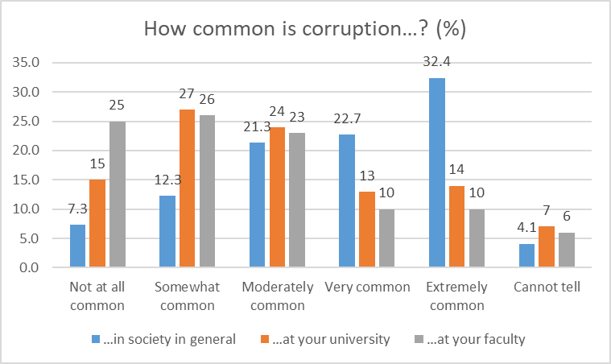

The second question that was posed to the Albanian university students was more explicit and relevant to the scope of the survey. To the question, to what extent does corruption affect the Albanian education system, 38 percent of the polled students answered ‘substantial’, that there was much corruption in the education system, and that education by and large remained fair. Almost the same percentage of the respondents, namely 36 percent, answered ‘devastating’, and that corruption had a very harmful impact on education quality. Only 4 percent of the polled university students claimed that there was almost ‘no corruption’ in the education system.
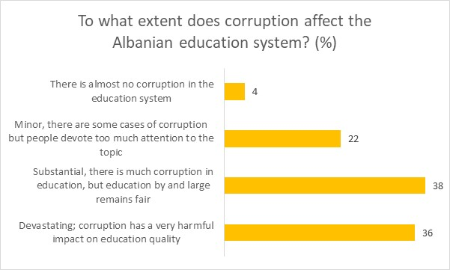
Fig.2 To what extend does corruption affect the Albanian education system? (%)

The polled university students were additionally asked on the rate of the impact of corruption on education to date. The largest percentage of the respondents, namely 40.7 percent answered that corruption had ‘no impact’ at all on their education, whereas 9.1 percent reported ‘some’ impact, and 19.8 percent claimed ‘little’ impact. Only 6.7 respondents answered that corruption has had ‘significant’ impact on their education. It has to be noted the high percentage of respondents that ‘prefer not to say’, and ‘does not know, cannot tell’ the rate of impact of corruption on education, namely 12.8 percent and 10.9 percent.

Fig.3 How would you rate the impact of corruption on your education to date? (%)
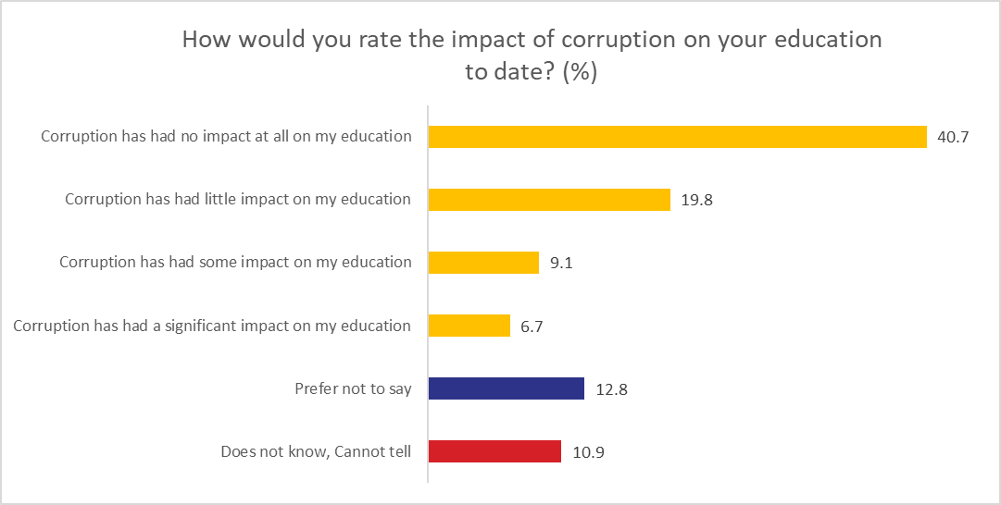

The 4th question posed to the polled university students concerned the expectations on whether corruption at their faculties was going to be more or less prevalent in the future. It is a positive country development that 31 percent of the polled Albanian students expected corruption to be ‘less prevalent’ in the future, compared to 22 percent that answered to be ‘more prevalent’. A high percentage of respondents, namely 23 percent claimed that corruption in the future will ‘remain the same’. Whereas 24 percent of the students answered that they ‘do not know, cannot tell’ whether corruption will be more or less prevalent in the future. In fact, this percentage of expectations is considerably high.
Fig.4 Do you expect corruption at your faculty to become more or less prevalent in the future? (%)
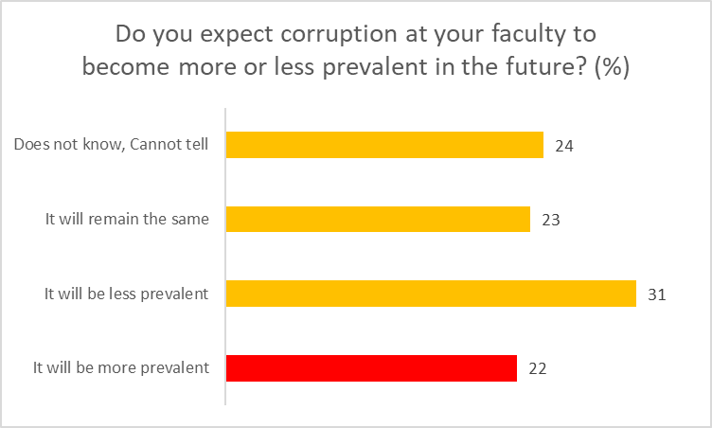

20 percent of the Albanian students responded that the most common form of undesirable behavior at their faculty was forcing students to buy textbooks in exchange to higher grades or passing the exams, to be followed by 19 percent of them that reported giving cash bribes to teachers in return for higher grades. Surprisingly, 24 percent of the respondents answered, ‘do not know, no answer’. This is a relatively high percentage to report no information on their perception, which may also impact the outcome of this poll question. Based on the data of the poll it is a positive country development that sexual harassment is not considered as a form of undesirable behavior at their faculties, as it is reported to be precepted as a common form of undesirable behavior only by 1 percent of the polled students. Other forms of undesirable behaviors, suchlike students paying to write their papers, doing favors to teachers in exchange for higher grades, and students paying to obtain degrees, are reported by 7 percent of the Albanian university students.
Fig.5 What do you feel is the most common form of undesirable behavior at their faculty? (%)
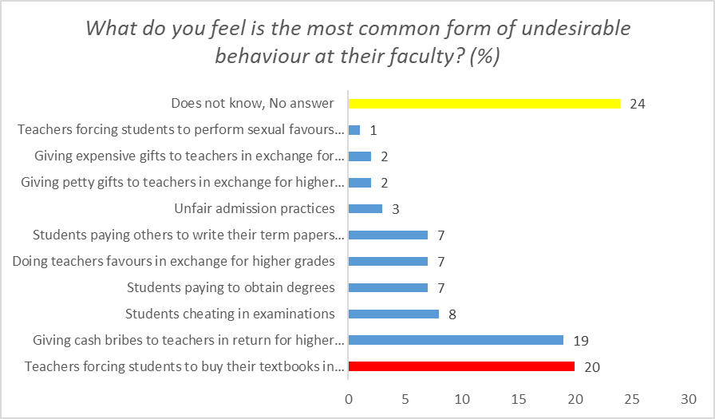

Question no.5 was further developed aiming to extend the perception of the university students. Most respondents, 56 percent, found ‘not at all common’ and denied teachers forcing them to perform sexual favors in exchange for higher grades. 25 per cent of the polled students shared the opinion that it is ‘extremely common’ for teachers to force students to buy their textbook to pass the exams. 20 percent of the students found it ‘very common’ to cheat in exams. Polled students found it ‘not at all common’ to do favors to the teachers, give expensive gifts or petty to teachers in exchange for higher grades, respectively, 39, 38 and 35 percent. The percentage of the respondents that answered ‘does not know, cannot tell’ is still very high to this question as well.
Fig.6 How common are the following behaviors at your faculty? (%)
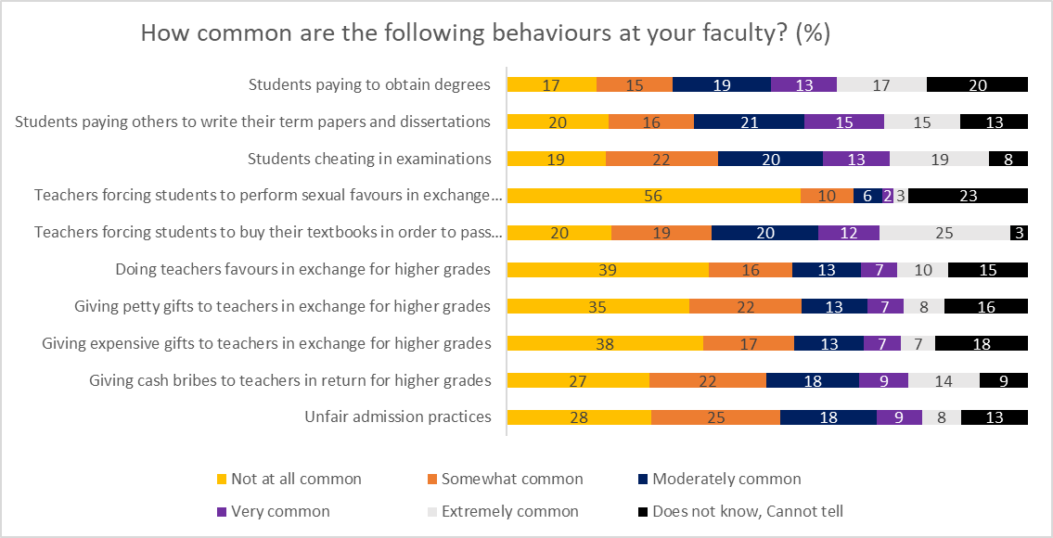

It is a positive indicator that a very high percentage (82 – 87 percent) of the polled university students have ‘never’ experienced any of the foreseen undesirable experiences since being enrolled to the faculty, i.e., offering a bribe or being asked for a bribe in exchange for a certain service at their faculty. A very small percentage of the respondents (2-3 percent) have reported that ‘multiple times’ have offered a bribe and/or have been asked for a bribe.
Fig.7 Since enrolling at this faculty have you ever experienced any of the following? (%)
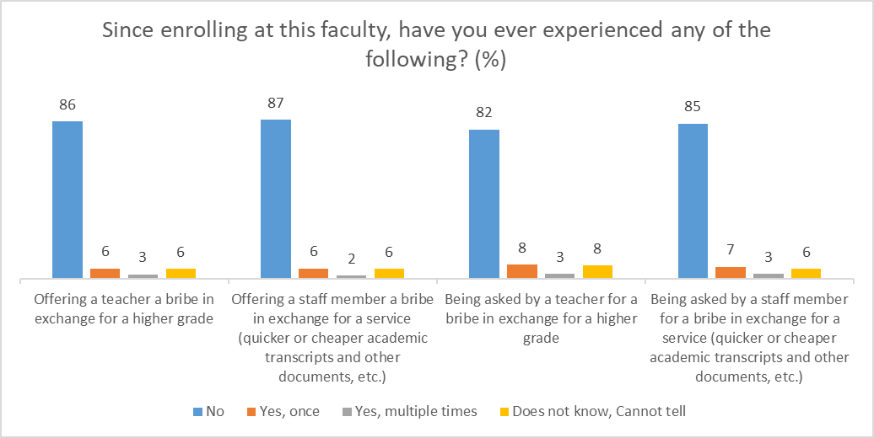

Figure no. 8 is a follow up of the 1st question of figure no.7 ‘Offering a teacher a bribe in exchange for a higher grade’. The majority of the polled university students, namely 11 of them, have reported that they have offered ‘money’, to be followed by ‘favors’, and ‘expensive present’, namely 5 of them. Only 1 student declared to have offered an intimate relationship.

Fig.8 What did you offer? (absolute numbers)
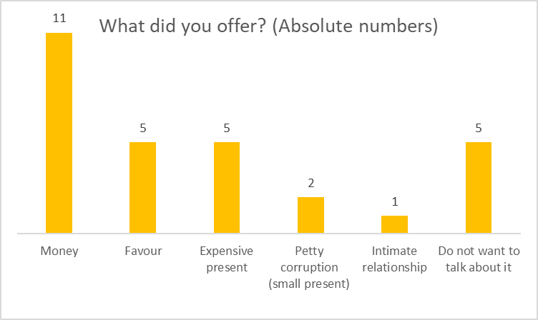
Figure no. 9 is a follow up of the 2nd question of figure no.7 ‘Offering a staff member a bribe in exchange for a service (quicker or cheaper academic transcripts, and other documents, etc.). Based on the answers of the Albanian students, 8 of them have declared that have offered ‘money’ to faculty staff members in exchange for a service, 6 others have offered ‘expensive present’, 4 of them offered ‘favors’, and 2 have declared to have offered intimate relationship.

Fig.9 What did you offer? (absolute numbers)
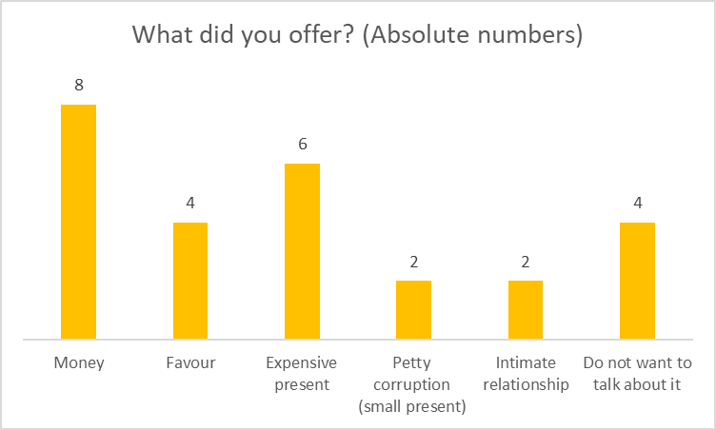
Figure no. 10 is a follow up of the 3rd question of figure no.7 ‘Being asked by a teacher for a bribe in exchange for a higher grade’. 21 Albanian students reported that were asked by a teacher to give ‘money’ in exchange for a higher grade. 5 of them were asked for an ‘expensive gift’, and the same number for a ‘petty corruption’. Only 1 declared that was asked for ‘intimate relationship’ in exchange for a higher grade.

Fig.10 What type of bribe were you asked for? (absolute numbers)
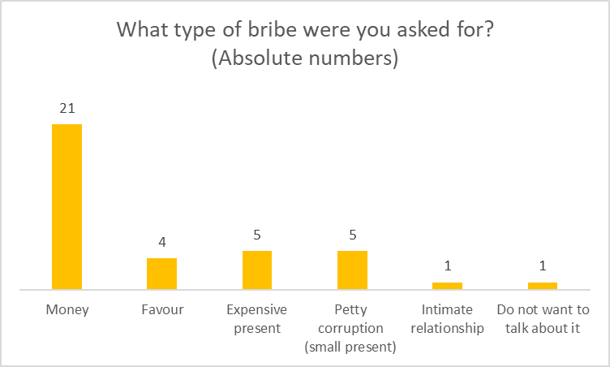

Figure no. 10 is a follow up of the 4th question of figure no.7 ‘Being asked by a staff member for a bribe in exchange for a service (quicker or cheaper academic transcripts, and other documents, etc’. 16 of the respondents answered that were asked by a staff member for ‘money’ in exchange for a service. 4 of the polled students reported that were asked for a ‘favor’, 3 of them for an ‘expensive gift’, and the same number was asked for a ‘petty corruption’. 6 of them answered that ‘do not want to talk about it’.

Fig.11 What type of bribe were you asked for? (absolute numbers)
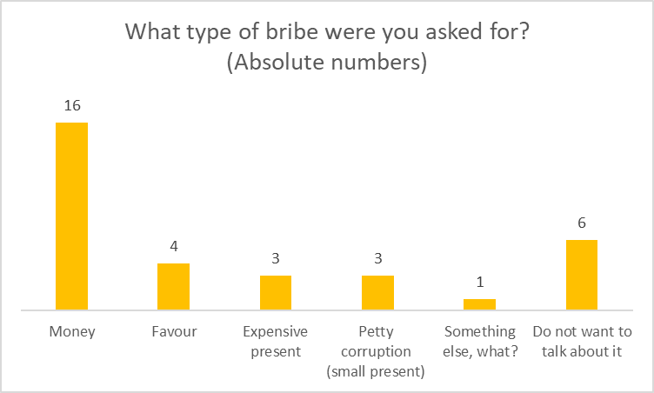

86 percent of the polled respondents answered that they have ‘not’, either formally or informally, reported a case of corruption to the management of the faculty. This is a considerable percentage, which clearly indicates that university students are not informed on the reporting mechanisms established within their faculty, they do not trust to these mechanisms, or the reporting mechanisms are just formally established, but they are not functional.

Fig.12 Have you ever reported a case of corruption to the management of your faculty?
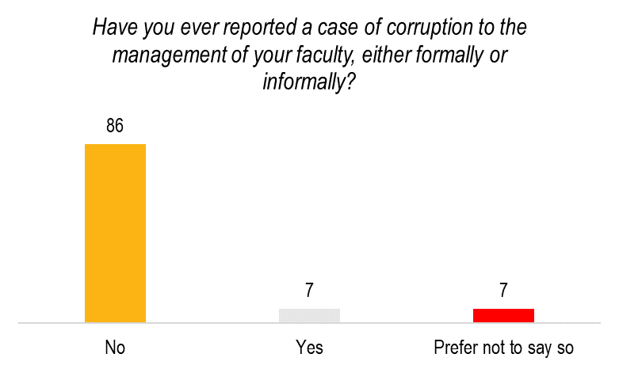
48 percent of the polled university students have ‘not’ faced retribution for reporting corruption. But when compared to the percentage of students that ‘have faced’ retribution, 35 percent of them, it is a high percentage, and it clearly indicates that universities and faculties have not taken the proper measures to ensure the confidentially of the students that file and report a corruption case. 17 percent of the respondents claimed that they ‘do not want to talk about it’, which is a considerable percentage that does not want to provide any feedback on this topic.

Fig.13 Have you ever faced retribution for reporting corruption? (%)
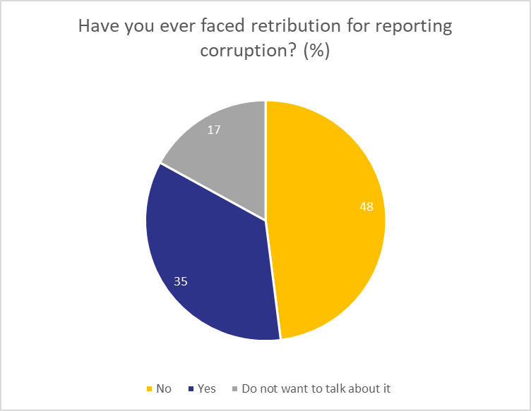

41 percent of the polled Albanian students claimed that they ‘do not know, cannot tell’ whether there is a dedicated office for reporting corruption. This is a very high percentage, which shows that students are not informed on the existence of such an office., or they are not interested to have this information, despite the fact that universities/faculties might have formally informed the establishment of this dedicated office. Considering the importance of this dedicated office, universities and faculties shall allocate more resources to the organization and functioning of the office to report corruption. Moreover, 38 percent of the polled students answered that their faculty ‘does not’ have any dedicated office for reporting corruption, notwithstanding the fact that the existence of such office is a legal requirement that high education institutions shall comply with.
Fig.14 Does your faculty have a dedicated office for reporting corruption? (%)
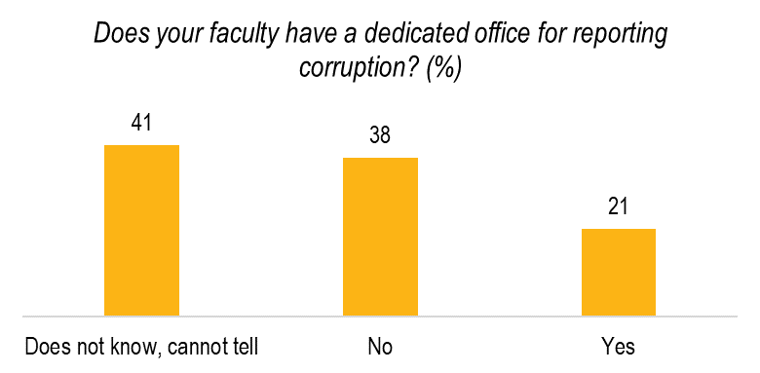

To the question to which extent do you think that the faculty’s management cares about corruption and treats it in the faculty, Albanian students shared different views. On a scale 1-5, 19 percent were completely dissatisfied (scale 1); 23 percent of the respondents belonged to scale 3; only 6 percent were completely satisfied, that is a considerably low percentage, and surprisingly 23 percent responded, ‘does not know, cannot tell’, which is a relatively high percentage.
To the question to which extent are you familiar with procedures to report corruption in the faculty, the polled Albanian students shared different views. On a scale 1-5, the majority of the polled students, 27 percent, were completely dissatisfied and not familiar with the procedures on reporting corruption (scale 1); 21 percent of the respondents belonged to scale 2; only 6 percent were completely familiar and satisfied with the reporting procedures. 23 percent of the respondents responded, ‘does not know, cannot tell’, which is a relatively high percentage.
To the question to which extent do you think that information regarding reporting corruption in the faculty is available to students, the majority of the polled students, 24 percent, were completely dissatisfied and not familiar with the availability of information regarding reporting corruption; 24 percent belonged to scale 2; only 6 percent were completely familiar and satisfied with the availability of information on reporting corruption, reporting procedures. The relatively high percentage of the respondents that answered, ‘does not know, cannot tell’, is also noted in this question, that is 20 percent.

Fig.15 To which extend do you think that faculty’s management cares about corruption and treats it?
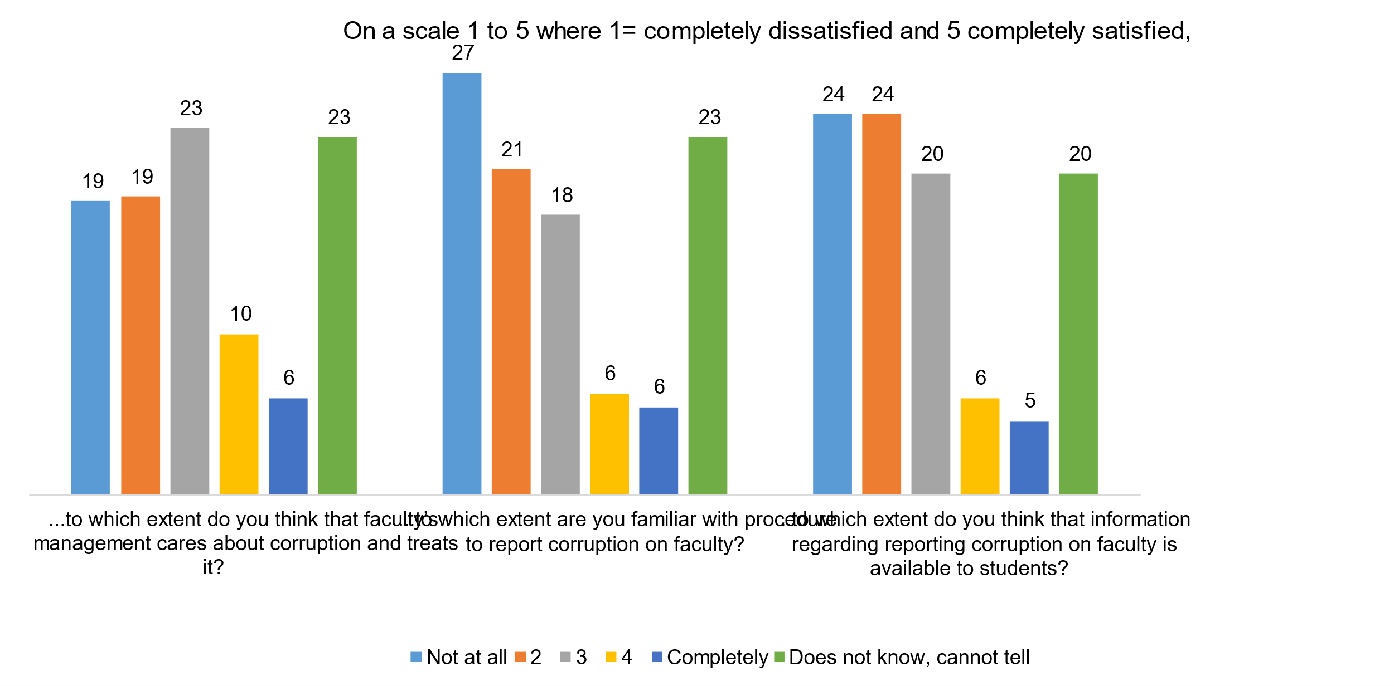

Establishing options for students to report corruption is very important as it shows the engagement of faculty’s management on prevention of corruption at high education institutions. Based on the results of the polled Albanian students, 50 percent found online form to report corruption, as the most convenient form, to be followed by ‘talking to someone from faculty management’, by 28 percent. This percentage is an interesting indicator of the trust that students want to establish with the faculty’s management and their readiness to communicate such issues with them.
Fig.16 What would be the most convenient option for students to report corruption?
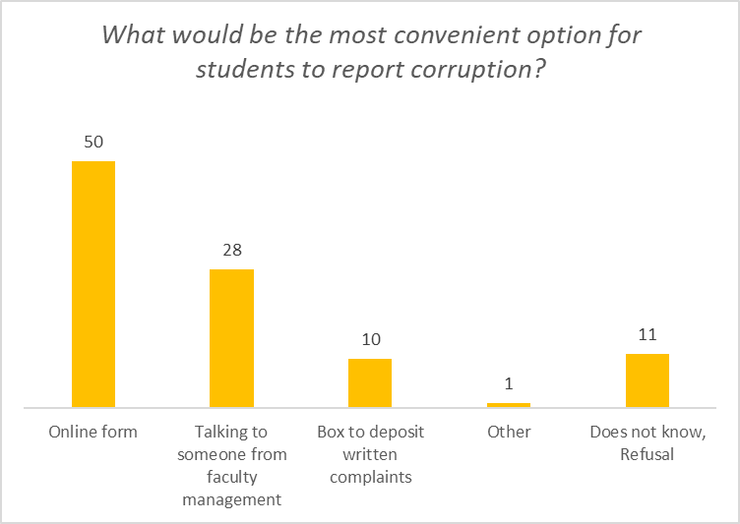

Most of those polled, 88 percent claimed they would always report corruption, but on the other hand, almost the same percentage, 86 percent of the students, answered they would be worried about possible retaliation. 60 percent of the respondents answered they ‘do not believe I could change anything’, which clearly shows the lack of trust in the established reporting mechanisms. Whereas 33 percent of the respondents were not able to provide a reason why corruption went unreported in some cases.
Fig.17 If you witnessed corruption at your faculty, is there a reason why would you refrain from reporting it?
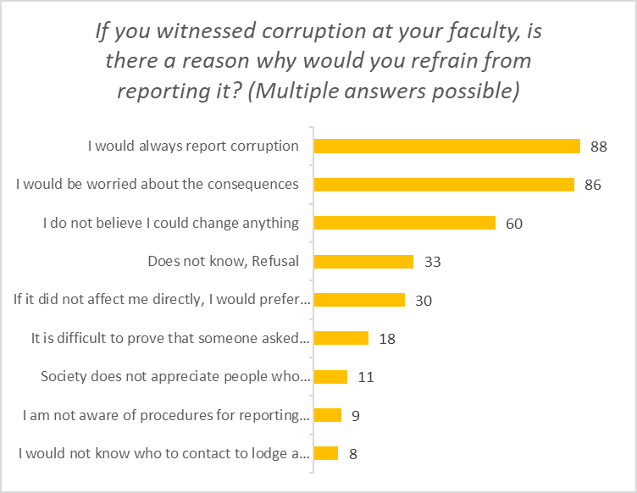

According to the results of the posed question, 24 percent of the Albanian students responded that ‘unclear procedures’ are the main reason why corruption is under reported in their faculty. In fact, it is a legal requirement that high education institutions shall establish clear rules and regulation on the modalities of reporting corruption. Lack of informing sessions and raising awareness of the students on the reporting procedures may be another cause for which ‘unclear procedures’ are claimed by the respondents. Almost the same percentage, 23 percent, is reported on the fact that ‘there is no interest in eliminating corruption’, indicating an explicit lack of interest to prevent or minimize corruption. ‘Does not know, refusal’ and ‘retribution against those who report’ are ranked in scale 3 and 4, namely 18 and 17 percent of the polled students.

Fig.18 What is the main reason why corruption is under-reported at your faculty?
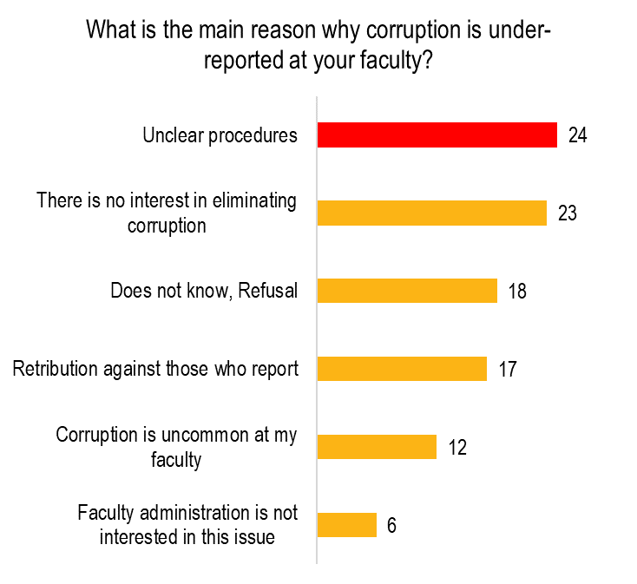

RECOMMENDATIONS FOR THE JOINT REPORT ON PERCEPTIONS OF CORRUPTION AT ALBANIAN UNIVERSITIES AND PERFORMANCE OF ANTI-CORRUPTION MECHANISMS

- Recommendations on the strategic framework

- It is a positive development that Albania has approved and is currently implementing the Inter-Sectoral Strategy Against Corruption 2015-2023, including the Action Plan 2020 – 2023. Nevertheless, we notice that there is a limited impact of anti-corruption measures in vulnerable areas of the country, including the education system. Therefore, a more intense and proactive anti-corruption approach, more anti-corruption measures and more specific activities on this topic should be reflected in the new Inter-Sectoral Strategy Against Corruption.

- Albania has recently approved the new National Strategy for Education, including the Action Plan 2021-2026. This Document is a positive step forward and it addresses specific activities to better channel corruption in the education system. We notice that corruption in the higher education system is addressed in a very limited number of objectives and activities. Therefore, no matter the meagre number of activities, their implementation is strongly encouraged, as it will serve at a later stage to further identify additional issues related to corruption in the HEIs.

- Recommendations on the institutional level (Ministry of Education and Sports) framework

- It is a well-known fact that there are no assessment reports, research studies or monitoring reports on the impact of corruption in the higher education system. The current report represents a very good initiative of civil society, namely of IDRA aiming to raise the awareness on this topic in the country, bring some hints and findings to the current country context on this topic. It is strongly suggested for Ministry of Education and Sports to cooperate with CSOs and other stakeholders, and further exploit this topic, identify problems in this sector and develop a more proactive approach towards the prevention of corruption in the higher education institutions.

- Recommendations on the legal framework for Higher Education Institutions

- Transparency and trust are the building blocks of any organization’s credibility. Nothing undermines effective institutions and businesses more than bribery, bringing about the lack of a culture of integrity, transparency and compliance. ISO37001 standard specifies requirements for an anti-bribery management system to prevent, detect and respond to bribery. It is a flexible tool, which can be adapted according to the size and nature of the organization and the bribery risk it faces. The use of quality management tools in Albanian institutions is still sporadic. HEIs should be oriented to cooperate with Minister of State for Service Delivery and Standards that is tasked to draft, coordinate and implement state policies, facilitating the provision of public services by ensuring their quality, affordability and increase effectiveness, consequently improving the lives of Albanian citizens. In this framework HEIs are suggested to apply quality management tools, in this specific case the adoption of ISO37001, as a crucial anti-bribery instrument.

- HEIs are strongly suggested to develop their integrity plans as part of their anti-corruption measures. HEIs should develop a risk assessment approach/policy, aiming to identify risks, assess them and develop mitigating measures for each of them.

- It is a positive development that HEIs have developed the Regulation on Conflicts of Interest and the Regulation on the Protection of Whistleblowers. Notwithstanding the formal existence and approval of these internal documents, HEIs shall develop internal mechanisms to ensure their implementation. Periodic monitoring on the level of implementation and compliance is crucial to be conducted on regular basis.

- It is a positive achievement that HEIs have already established the dedicated units on the protection of whistleblowers. It clearly indicates the commitment of HEIs to comply with the legal requirements. On the other side, HEIs are strongly recommended to ensure the efficiency of these Units and raise the awareness of the university students on the importance of such dedicated units. Organisation of informing sessions or awareness raising campaigns may be useful instruments to promote these offices aiming their efficiency.

- HEI shall ensure the confidentially and the protection of personal data, especially concerning denunciation of corruption, by developing dedicated policies and internal regulations on this issue.

- Recommendations in connection with students’ perceptions of corruption

- 27 percent of the students found corrupt practices as ‘very common’ or ‘extremely common’ at their university, and 20 percent they were ‘very common’ or ‘extremely common’ at their faculty. Whereas 38 percent of them believed corruption impacted the education system substantially. Such data indicates that there is a high level of perception of corruption in the universities/faculties. This stipulates the need to raise awareness on corruption, by organizing various and periodic events for the students, aiming for a better understanding of corrupt practices, and how students can significantly contribute to address them and minimize corruption.

- Forcing students to buy textbooks in exchange for higher grades or passing the exams, and giving cash bribes to teachers in return for higher grades were identified as the most common forms of undesirable behavior at the faculty. This is a good indicator for HEIs to take actions to build capacities of the students to report such practices. Development of standard operating procedures on reporting undesirable behavior is a key element to be strongly considered by HEIs.

- 86 percent of the students answered that they have not, either formally or informally, reported a case of corruption. 41 percent of the respondents claimed that they do not know, cannot tell whether there is a dedicated office for reporting corruption. HEIs shall take advantage of such data and take concrete measures to restore the confidence and trust of the students to report corruption practices. Some of these measures may lead to the organization of periodic informing sessions, introduction of the reporting procedures, presentation of concrete reporting cases would help to showcase and build confidence in such reporting mechanisms.

- The establishment of various internal mechanisms is crucial to report the corruption related cases. HEIs are strongly recommended to create a comfortable environment (informing sessions, briefings, organisation of students’ forums, introduction of concrete reported cases, etc) for the students and encourage them to report any inappropriate behaviour. This would lead to a mutual trust between the students and the management of the faculty.

- 86 percent of the students claimed that they refrain themselves from reporting corruption as they would be worried about possible retaliation. In order to encourage students to report corruption practices or undesirable forms of corruption, HEIs shall develop clear policies and standard procedures to avoid such doubts. Introducing various options and modalities on reporting corruption would change the perception of the students.

- Last, but not least, HEIs are strongly suggested to conduct online surveys for their students on corruption related issues, students’ perception, reporting mechanisms, the functioning of reporting offices, and other related issues, aiming the efficiency of reporting channels, the identification for further improvements, and building of students’ trust to the management of the faculty. Through this approach, HEIs would address issues related to unclear reporting procedures that may also lead to the perception that there is no interest to eradicate corruption, as it was claimed by 23 of the polled students.

I. CHAPTER 2: LEGAL AND INSTITUTIONAL ANTI-CORRUPTION FRAMEWORK FOR THE HIGHER EDUCATION OF THE NORTH MACEDONIA

Legal framework
Ever since gaining independence two decades ago, the Republic of North Macedonia (RNM) has constantly been in the reformation process which, above all, is normative and institutional in nature. The reforms have been implemented in public administration, judiciary, economy, and other sectors, and consist of implementing European criteria and standards in order to meet the requirements for EU membership. One of the areas in question is the higher education (HE). North Macedonia is one of the countries which joined the Bologna Process and ratified the Bologna Declaration in 2003.
The first Law on Higher Education after the independence of the country was adopted in 2000. A new Law on Higher Education was adopted in 2008. This Law established the normative and legal frameworks for the development of higher education in accordance with the Bologna Process, the implementation of European standards and criteria, which contributed to bringing domestic higher education closer to the European one, the implementation of European dimensions in the curricula and recognition of acquired higher education qualifications which strongly affect the acceleration of the social and economic development of the Republic of Macedonia. A new Law on Higher Education was adopted in 2018. The main novelties in higher education were the establishment of the Agency for Quality in Higher Education (AQHE) (16.01.2020); establishment of the Higher Education Accreditation Board (March 12, 2020), and the Higher Education Evaluation Board (March 12, 2020). All by-laws of the Law on Higher Education within the competence of MES were adopted. All documents are uploaded on the official website of the Agency for Quality in Higher Education http://akvo.mk/index.php (Rulebook on Methodology, Standards, and Procedure for Accreditation of Higher Education Institutions and Accreditation of Study Programs (adopted by the National Council for Higher Education), Rulebook on the Standards and Process of External Evaluation and Self-evaluation (adopted by the National Council for Higher Education)).
This Report analyses the legal framework that regulates the higher education, that is, notes the provisions vital for the prevention of corruption, as well as analyses of the responses to the survey regarding students’ perception of corruption in the higher education.

Laws
In accordance with the Constitution of RNM, everyone is entitled to education. Education is equally available to everyone. Additionally, the Constitution guarantees the University autonomy, and the conditions for establishment, practice, and termination of University activities are regulated by law.
The current Law on Higher Education was adopted in 2018 and it is the most important regulation act regarding higher education in RNM. This law shall regulate the university autonomy and its academic freedom, conditions and procedure of establishment, status changes and termination of higher education institutions, their activities, system for assuring and evaluating the quality of higher education, fundamentals for its organization, management, development and financing higher education activities, rights and obligations of students, recognition of foreign higher education qualifications, and supervision of the work of higher education institutions.
Regarding the integrity and prevention of corruption in higher education, we would note that the LHE contains specific provisions which include aspects where risk of corruption may appear. Above all, we refer to the provisions pertaining to the procedure of establishing a higher education institution, accreditation of higher education institutions, termination of a higher education institution, revoking the right for performing higher education activities by a higher education institution, election, structure, competences, and operations of the University bodies – University Senate, Rector, and Rector’s office, election, structure, competences, and work of bodies of a University units – Teaching-Scientific Council, Dean and Dean’s office, it also regulates the funding and property management of the HE institutions, curricula, the election procedure for teaching-scientific; teaching-professional, teaching, scientific, and fellow titles, the rights and obligations of students, as well as supervision over the operations of the HE institution.
LHE’s provision regarding the authorized person for receiving reports on corruption is very significant, so aiming to have more efficient prevention and protection against corruption, University Senate elects a person amongst full-time professors who is given the authority to receive corruption reports. This person authorized to receive corruption reports is elected for a period of three years and entitled to a second re-election. During the course of his or her work a report has to be submitted to the University Senate at least twice a year.
When it comes to students, amongst other students rights guaranteed by the LHE regarding corruption prevention we would highlight the participation in the management of the HE institution in accordance with this Law and the Statute of the HE institution, the right to protect personal rights and duties of the HE institution bodies, as well as the right to protect the student against abuse and his/her dignity. In order to protect the students’ rights, each University elects a Student Ombudsman who comes from the pool of its enrolled students. Student Ombudsman acts upon pleading from a student or upon personal initiation if it has been brought to his or her attention that a student’s right has been violated by a University body or by any another member of the academic community of the University. The HE institution bodies are bound to act once the Student Ombudsman points out the issue. The Deputy Student Ombudsman acts upon student pleading or upon personal initiation if it has been brought to his or her attention that a student’s right has been violated by a Faculty body or by another member of the academic community of the Faculty. The Faculty bodies are bound to act once the Deputy Student Ombudsman has brought an issue to their attention. Student Ombudsman submits an annual report to the university Senate regarding his/her work. Deputy Student Ombudsman submits an annual report to the Student Ombudsman and to the Teaching and Scientific Council unit. The LHE also regulates the students organization and their participation in management.
Regarding the competences of the University Student Assembly, we would highlight the tending competence for the quality of life and the studying process, student standard, exerting students’ rights and interests, as well as encouraging students to grow culturally, socially, and intellectually. Additionally, students participate in the management of HE institutions through their elected representatives in the:
- University Student Assembly, Faculty Student Assembly, and the Post-Secondary Vocational School Assembly,
- HE institutions’ bodies in accordance with the Law,
- via self-organization or
- other manners in accordance with the conditions determined by Law and the HE institution Statute.
The LHE also regulates the system for assuring, evaluating, developing, and improving the quality of HE which includes:
- approving, validating and recognizing the HE institution and its curricula, performing HE activities in accordance with this Law, which is implemented by an accreditation system;
- evaluation of the performance quality of the HE activities, management, funding, academic and other activities, and its priorities, implemented by an evaluation system and
- other activities and mechanisms aimed at developing and maintaining the HE quality, which are regulated by the Law and the acts of the National Council for Higher Education, and the teaching-scientific activities.
At the same time, the LHE regulates that the system for assuring, evaluating, developing, and improving HE is realized through the National Council for Higher Education and Research Activities, and the Agency for Quality in Higher Education. The National Council for Higher Education and Research Activities shall be established in order to ensure, evaluate, develop, and improve the quality of higher education and research activities in the Republic of Macedonia. Among other matters, the National Council monitors the development of HE and its compliance with European and international standards, and therefore it submits an annual report to the Parliament and the Government of the Republic of Macedonia including proposed measures, solutions, and recommendations for improvement of the higher education activities, and, upon an approval from the minister competent for higher education, drafts and proposes the National Program for Higher Education to the Parliament of the Republic of Macedonia for adoption. The LHE additionally lists the competences of the National Council.
The Law on the National Qualifications Framework shall regulate the National Qualifications Framework, the qualification levels and sublevels, qualification scope, competent bodies for proposal, adoption, and classification of qualifications, competent institutions which shall act in accordance with this Law, as well as aligning the National Qualifications Framework to the European Qualifications Framework, and to the Qualifications Framework of the European Higher Education Area.
The Law on Educational Inspection shall regulate the organization, competences, and authorities of the educational inspection conducted by the State Educational Inspectorate and its authorized inspectors from the Municipality and the City of Skopje. In accordance with this Law, higher education shall also be subject to supervision, and while conducting the inspection supervision, the state educational inspector is granted additional authorization regulated by law.
The Law on Prevention of Corruption and Conflict of Interest shall regulate the measures and activities for prevention of corruption in exercising authority, public authorizations, duties and politics, measures, and activities for prevention of corruption while performing matters of public interest by legal entities related to implementation of public authorizations. The State Commission for Prevention of Corruption is competent to enforce these measures and activities. The provisions regarding prevention of corruption in exercising public authorizations, which regulate prohibition to perform other activities, limitation of performing activities during discharge of duty, limitation of supervising, prohibition to influence in order to employ close relatives, prohibition to receive presents, bribes, to abuse while carrying out matters of public interest, and other illegal actions are of also special significance.
The Law on Whistleblower Protection shall regulate protected disclosure of information, the rights of whistleblowers, as well as the actions and obligations of institutions, that is, legal entities regarding protected disclosure in the public and private sector in order to protect public interest and ensure whistleblower protection. In accordance with this Law, protected disclosure of information shall represent disclosure, that is, divulgence, which, in accordance with this Law, communicates reasonable suspicion or information that a punishable, unethical, or other illegal or impermissible action which violates or endangers public interest has been, is being, or is going to be committed.
The Law on Free Access to Public Information shall guarantee transparency of the work of institutions, which is one of the key mechanisms in corruption prevention. This Law shall regulate the conditions, manner, and proceeding for exercising the right to free access to public information possessed by the bodies of state power and other bodies and organizations laid down by Law, Municipal bodies, bodies of the City of Skopje and its comprising municipalities, institutions and public services, public enterprises, legal and physical persons carrying out public authorizations laid down by law, and activities of public interest and political parties pertaining to income and expenditure, which are considered possessors of information. This law contains the procedure for exercising the right to free access to public information, and a separate provision which contains all data meant to be made public by possessors of information.

1.1.2 By-laws

Rulebook on the Methodology, Standards, and Procedure for Accreditation of Higher Education Institutions and for Accreditation of Study Programs, which prescribe the methodology, standards, and procedure for accreditation of HE institutions, and curricula accreditation, as well as other matters related to the work of the Higher Education Accreditation Board has been adopted on the grounds of the LHE. The work of the Accreditation Board is based upon the Methodology on standards and conditions regulated by this Rulebook, the Rulebook on Norms and Standards for Establishing HE Institutions and for Performing HE Activities, the Regulation on the National Framework for HE Qualifications, the conditions set down in the project for establishing an independent public, private-public, or private higher education institution, that is, in the elaboration on the curriculum accreditation with the purpose of assuring, evaluating, developing, and improving the quality of higher education, which includes:
- approving, validating and recognizing a HE institution and curricula, with the purpose of performing HE activities realized through the Accreditation System;
- other activities and mechanisms through which the quality of higher education is developed and maintained, which are laid down by the Law and the acts of the National Council for Higher Education and the teaching and scientific activities.
The procedures for accreditation of the HE institutions and the curriculum shall be implemented in accordance with the standards and directions within the European Association for Quality Assurance in Higher Education for assuring equal HE quality as the one in the European Area.
The Rulebook on Standards and Norms for Establishing Higher Education Institutions and for Performing Higher Education Activities shall regulate the standards and norms which must be met in order to establish higher education institutions and to perform higher education activities.
The Rulebook on the Standards and Norms for Establishing Scientific Institutes and Performing Research Activities shall regulate the standards and norms which must be met in order to establish scientific institutes such as University units oriented towards science, public, hybrid, and private scientific institutions (research institutions), and independent researchers.
Additionally, a Rulebook on the Standards and Procedure for External Evaluation and Self-Evaluation which prescribes the standards and procedure for performing external evaluations and self-evaluations of the System for Quality Assurance in Higher Education in the Republic of North Macedonia has been adopted.
Pursuant to the Law on Whistleblower Protection, the following by-laws have been adopted: The Rulebook on Protected Internal Reporting in the Public Sector Institutions, Rulebook on Conducting Procedures for Receival of Whistleblower Disclosures, Sorting and Processing Data from the Reports with the Purpose of Assuring Protection of Personal and Other Data Pertaining to Whistleblowers while Applying the Provisions on Personal Data Protection and Classified information Protection.
Other more significant by-laws are the University Statute, the Faculty Statute, the Rulebook on Criteria and Procedure for Elections in Teaching-Scientific, Scientific, Teaching and Professional and Fellow Titles and Doctoral Research Assistants, Rulebook on the Conditions, Criteria and Rules for Enrollment in First and Second Cycle University Studies and so on.

1.1.3. Strategies
RNM has also adopted the Education Strategy of the Republic of Macedonia for 2018-2025 and related Action Plan, which represents the basis for the activities of the institutions in the Republic of Macedonia in the field of education for the period until 2025. Its starting point is the current state-of-play of the education system, and its goal is to gradually improve them in accordance with the laid down priorities. The Strategy is grounded on clearly laying down the main challenges in the education sector which assures its relevance through careful definition of priority areas to concentrate on in the period until 2025.
RNM has also adopted a National Strategy for Prevention of Corruption and Conflict of Interest 2021-2025, which notes in the section regarding education certain inconsistencies, and lists measures and actions which need to be taken for the purpose of overcoming those issues. What needs to be pointed out is the information in the Strategy which states that “it has been detected that corruption in HE is evidently high, which is additionally confirmed by court rulings”. Additionally, “in what manner is another segment from the education sector related to accreditation of higher education institutions, research institutions and curricula, for which it is necessary to ensure higher transparency of the establishment and operations of the appropriate competent bodies”. This Strategy notes the low awareness about addressing the corruption and conflict of interest within education institutions. Consequently to the stated, there is a necessity for systematized activities to strengthen the awareness in this sphere.
Ministry of Education and Science has also adopted an Integrity Policy which stipulates that the integrity system rests on the elements pertaining to the protection of public interest and prevention of the conflict of interest, respecting the code of ethics, management of human resources on the grounds of the merit system, earmarked, rational, and efficient management of public resources, transparency and access to information, protected disclosure from whistleblowers and quality management. Additionally, the Minister for Education has adopted an Annual Plan for Corruption Risk Assessment for 2023,
For the purpose of strengthening the integrity of employees with the status of civil servants, a Code of Ethics for Civil Servants, which prescribes the ethical standards and manners of conduct of civil servants, with the goal of encouraging good performance and conduct of civil servants and strengthening the confidence of citizens in the work of public sector institutions. Additionally, Codes of Ethics for Universities were adopted which apply to all members of the academic community and employees (teaching, fellow, research, administrative, technical staff, as well as students) in professional and public activities.

1.2. Institutional framework
When it comes to the institutional framework, we can conclude that, at central level, there are several institutions with competences for specific affairs pertaining to higher education. By this, we refer to, above all, the Ministry of Education and Science (MES) and the State Educational Inspectorate (SEI). MES as a central, autonomous, and unaffiliated body of the state administration whose competences are laid down in the Law on Organization and Operation of the State Administration Bodies. As a MES comprising body, the State Educational Inspectorate plays a special role. In accordance with the Law on Educational Inspection in higher education institutions and research institutions, the State Educational Inspectorate supervises the implementation of laws which regulate higher education activities on matters regulated by this law. Additionally, the State Educational Inspectorate supervises the enforcement of laws, other regulations, and general acts which regulate university dormitories and high school dormitories. Out of the issues closely related to the matter of our research, that is, prevention of corruption in higher education, we would point out the following competences of the State Educational Inspectorate, which are related to supervising: the existence of condition for performing activities in the educational, higher education and research institutions, high school dormitories, university dormitories, the procedure for election in teaching, teaching and scientific, scientific, and fellow titles; realization of teaching plans and programs, and other prescribed standards and norms which regulate educational activities; announcing an open call for enrollment of students and for accommodation of students in dormitories; pedagogic recordkeeping and documentation, as well as their issuing and application in preschool, primary, high school, and higher education, and high school and university dormitories; application of the norms on the number of wanted teachers and associates, and the size of the group of regular students in higher education institutions; the procedure for approval of study programs in higher education; the enforcement of the legal regulation in higher education and scientific institutions, and enforcement of the legal regulation from the field of prohibition and prevention of unregistered activities in educational institutions, in higher education institutions and in scientific institutions. The State Educational Inspectorate performs supervision through: integral evaluation of educational institutions, regular inspection supervision, extraordinary supervision, and control supervision. Extraordinary supervision is performed on the grounds of initiative from students, parents, parents’ council, employees of the educational institution, and other citizens. Control supervision is performed upon the expiry of the period for resolving issues determined by the inspection. While doing so, the state educational inspector has additional authorizations provided for by law.
The MES website has a special tab for protected internal disclosure of information where data on persons authorized for protected internal disclosure of information, as well as acts pertaining to disclosure. Namely, interested persons can learn more about the content of the Rulebook on Enforcement of Procedures for Receival of Whistleblower Disclosure, Sorting, and Processing of Disclosed Information and Taking Measures for Assurance of Protection of Personal and Other Data Pertaining to Whistleblowers and Whistleblower Reports While Applying the Regulations for Personal Data Protection and Classified Information Protection, adopted by the Minister for Education and Science, Rulebook on Protected Internal Reporting in Public Sector Institutions, adopted by the Minister for Justice, as well as the Action Plan for Prevention of Corruption 2021-2022 drafted by MES in accordance with the National Strategy for Prevention of Corruption and Conflict of Interest 2021-2025, for drafting an Annual Plan for Prevention of Corruption.
In RNM, higher education activities are performed by 28 higher education institutions, both state and private universities. Higher education institutions are among those who have most direct contact with students, and, in fact, reflect the students’ perception of higher education, which is why mechanisms for prevention of corruption should be most affirmed and implemented in these institutions.
In 2021, the Assembly of RNM adopted a decision on election of members of the National Council for Higher Education and Research Activities. The National Council for Higher Education and Research Activities shall be formed in order to ensure, evaluate, develop, and improve the quality of higher education and research activities in the Republic of Macedonia, with its authorizations laid down in the LHE.
The Agency for Quality in Higher Education (AQHE) is an independent professional body located in Skopje, RNM. The bodies of AQHE include: The Higher Education Accreditation Board, the Higher Education Evaluation Board, and the Director of the Agency for Quality in Higher Education. The Higher Education Accreditation Board and the Higher Education Evaluation Board, bodies of AQHE, were constituted in 2020. AQHE ensures realization of the system for assurance, evaluation, development, and improvement of higher education in RNM, as well as maintaining the quality standards, and promoting and improving the quality of HE institutions and their curricula (in accordance with the accepted standards and procedures of the guide enforced by the European Association for Quality Assurance in Higher Education). The competences of the Higher Education Accreditation Board and the Higher Education Evaluation Board are laid down in the LHE. The Accreditation Board plays an especially significant role in the curricula accreditation. Based on the report of the HE evaluation commissions, the Evaluation Board monitors the activities of higher education institutions which are accredited and received a decision on start of activities, and monitors and evaluates the quality of the performance of higher education activities, research, art, and professional activities of the academic staff of higher education institutions, and especially that of their curricula at least on five-years basis, and based on that, it provides proposals to the Accreditation Board for continuation or revoking the accreditation.
With reference to the reporting corruption, there are several significant institutions: the higher education institution itself, and the State Commission for Prevention of Corruption and Conflict of Interest (SCPCCI). Namely, in accordance with the Law on Whistleblowers, a person can make an internal or an external report, if the internal report is chosen, it is submitted in the very HE institution, that is, to the person authorized to handle whistleblower reports, and if it is a matter of an external report, the person can make a report to the Ministry of Internal Affairs, the competent Public Prosecutor’s Office, the State Commission for Prevention of Corruption, the Ombudsman of the Republic of Macedonia, or other competent institutions.
From the conducted positive law analysis, one can conclud that there is a good and broad legal framework which regulates protection from corruption in higher education. At the same time, there is a good institutional framework, that is, there are separate institutions where corruption can be reported, and which possess the competences to handle reports and take appropriate measures.

II. Survey with students

2.1 Methodology
Survey performed by | Institute for Strategic Research and Education and M-Prospect Agency
Fieldwork | May 2023
Sample type and size | Random, representative sample of 300 Macedonian university students. During preparation of sample, shares of respondents from different universities were made according to proportion, but also considering importance of statistical significance for smaller universities.
Sample frame | Ss. Cyril and Methodius University – Skopje, St. Kliment Ohridski University – Bitola, University of Tetovo and Goce Delcev University – Shtip.
Survey method | Questionnaire administered face-to-face to students attending sample universities
Survey instrument | 48-item questionnaire

2.2 Sample demographics
Gender: women, 57.5%; 42.5 men, %
University: Skopje 49%; Bitola 16.7%; Tetovo 18%; Shtip 16.3%
Faculty:
University year: Year 1, 32.4%; Year 2, 23.5%; Year 3, 21.9%; Year 4, 18.3%; Final Year, 3.9%.

2.3 Summary

In your opinion, how …do you think corruption is spread at your university? In your opinion, how …do you think corruption is spread at your faculty?

A total of 12.4% of students surveyed believe that corruption in Universities is largely present. At faculty level, this percentage is lower and totals 7.2%.

Based on your opinion, how large is the influence/impact of corruption to the educational system of our country?

The largest percentage, 40.2%, of students surveyed believe that in our country, the effect of corruption on the education system is large, but overall, education is fair. While 20.9% believe that the effect of corruption is minimal, that is, there are very few cases of corruption, but people worry too much about the topic. This high percentage of students who believe that corruption affects the education system should not be overseen, and appropriate measures should be taken to ensure that this percentage is reduced. Yet, what should be noted is that despite the high percentage, pertaining to the general matter, but if we take into consideration the answers to the subjective questions in the text below, that is, how directly they faced corruption during their education, we will see that that percentage is much lower than this.
How would you rate the influence of the corruption on your education so far?

To the question of how they would rate the previous effect of corruption on their education, the majority, 47.5%, of the surveyed believe that corruption has not affected their education. While 22.4% of the surveyed stated that corruption has affected their education. This percentage of 14.4% suggests that students do face certain forms of corruption, which affects their education, so from here on out, all measures, before all, educational measures, should be taken in order to prevent any form of corruption in higher education.
Do you expect that corruption will be more or less present on your faculty in the future?

Regarding the question whether students expect corruption to be more present or less present at their faculty in the future, 31.4% believe that nothing will change, while 28.1% believe that it will be less present. What should also be noted is that 23.5% of the students surveyed believe that in the future, corruption will be more present.
What would you say is the most common type of unwanted behaviour on your faculty?

Regarding the forms of corruption, 21.3% of students surveyed list cheating on exams as the most common type of unwanted conduct at the faculty, while conditioning students to buy a book written by the professor in order to pass an exam or get a better grade is second with 20.2%. Other forms include Applying unfair university admission procedures 11,2%, Giving money to a professor to get a better grade/result 9%, Giving expensive present to a professor to get a better grade/result 1,5%, giving small present to a professor to get a better grade/result 1,1%, Providing a favor to a professor to get a better grade/result 3%, Professors condition students to get intimate with him/her in order to pass exams 0,7%, Students use paid services to have their papers or thesis prepared 13,9%, Students buy diplomas 4,9%, DNK, Cannot estimate 13,1%.
Since the beginning of your education at this faculty, have you ever been in one of the following situations? To offer a bribe to one of your professors to get a better grade/result

When asked whether they had been in a situation where they offered bribe to a professor in order to get a better grade, 91.2% of the students surveyed stated that they had not, 3.9% stated that they had been in that situation only once, whereas 2.3% stated that they had been in that situation on multiple occasions.
Since the beginning of your education at this faculty, have you ever been in one of the following situations? To offer a bribe to employee of the faculty in exchange for a service

Regarding the question whether the students had been in a situation where they offered bribe to an employee of the faculty in exchange for a service, 93.1% of the students surveyed stated that they had not, whereas 3.6% had been in that situation.
Since the beginning of your education at this faculty, have you ever been in one of the following situations? To be asked for a bribe by one of your professors in exchange for a better grade

Regarding the question whether from the beginning of their education, any of the students surveyed had been asked for bribe in exchange for a better grade by a professor, 87.3% of the students surveyed stated that they had not, 4.9% stated that they had only been in that situation once, whereas 4.2% stated that they had been in that situation on multiple occasions. This information should be taken into consideration because it suggests that during their education, some students face corruption. The only mechanism for prevention of this occurrence is to report it, and to ensure that the authorized person and the competent institution take appropriate action to resolve these matters.
What type of bribe did they ask of you?

Regarding what type of bribe they were asked to provide, students which had been asked for bribe stated that it was money (5.2 %), while 3.3 % stated that it was a service.
Did you accepted to give a bribe?

3.3 % of students which stated that they had been asked for bribe stated that they did not accept, while 4.6 % stated that they had paid the bribe which they had been asked.
Since the beginning of your education at this faculty, have you ever been in one of the following situations? To be asked for a bribe by employee of the faculty in exchange for a service

Regarding the question whether any of the students surveyed had been asked for bribe in exchange for a service by an employee of the faculty, 94.4% of the students surveyed stated that they had not, 1.3% stated that they had only been in that situation once, whereas 1% stated that they had been in that situation on multiple occasions.
Have you ever reported a corruption case to the faculty management, either officially or unofficially?

Regarding the question whether any of the students surveyed had reported a case of corruption to the faculty’s management, officially or unofficially, 93.8% stated that they had not, whereas 3.3% stated that they had reported a case of corruption. The low percentage of reporting cases of corruption must be highlighted because it indicates that if it is not reported, corruption may continue to appear.
Have you ever faced any negative consequences for reporting corruption?

Of the students that had reported cases of corruption, 1.6% stated that they had not faced negative consequences for making a report, while 1.6% stated that they had faced negative consequences.
Is there a dedicated complaint office at your faculty to report corruption?

When asked whether their faculty has a special office for complaints on corruption allegations, 58.8% believe that it does not, while only 3.3% believe that it does, while 37.9% were unsure. This information must be taken into consideration because it indicates some students are not informed enough about where they can report cases of corruption.
Have you ever sought support of a students’ organization or union when reporting an instance of corruption?

When asked whether they had ever asked for support from a student organization or union when reporting a case of corruption, 22.5 % stated that they had not, 2.9% stated that they had, while 74.5% stated that they had never reported corruption. This information indicates that in the future, student organizations must be more involved in exerting the rights of students.
To which extent are you familiar with procedure to report corruption on faculty?

When students were asked how familiar they were with the faculty’s procedure for reporting corruption, 35.6% stated that they were dissatisfied.
To which extent do you think that information regarding reporting corruption on faculty is available to students?

When asked to which extent they believed that information regarding reporting corruption on their faculty was available to students, 40.2% stated that they were completely dissatisfied.
What form of reporting do you find the most suitable for students?

Most of the students surveyed found that the most suitable form of reporting corruption was online (41.8%), while 28.8% considered notifying and talking with faculty management to be a suitable form.
What is the main reason for low level of reporting of corruption on your faculty?

According to 33.3% of the students surveyed, the main reason for the low level of reporting corruption on their faculty are the repercussions for the person that files the report, 24.2% believe that there is no interest in eradicating corruption, while 19% believe that corruption is rare on their faculty, and 8.8% believe that the procedures are unclear.

Based on the analysis of the students’ responses, we can make the following several conclusions:
- At university level, and even more at faculty level, the perception of corruption in higher education is not very widespread. Even despite the low percentage, no opinion on students who have faced or might face corruption during their education process should be disregarded, so in the future, all activities which would contribute to a stronger system for higher education, education with integrity and quality should be encouraged.
- Additionally, there are cases of students which stated that they had offered bribe or had been asked for bribe. This situation must be overcome by increasing the awareness and integrity of students, as well as that of the teaching and non-teaching staff.
- Students believe that a separate office for reports of corruption does not exist and consider e-reports to be most suitable. Bearing this in mind, it is considered that students need to be educated on all the available mechanisms for reporting corruption and protection of their rights and interests. This indicates that students are not informed enough on where and how they can report corruption, and that they do not use the opportunities of student organizations regarding the exertion of their rights.
- Nevertheless, students believe that the main reason for not reporting corruption are the repercussions, that is, the negative consequences regarding the further completion of their studies.

III. Research - Responses to requests for free access to public information

In order to obtain significant empirical information on public sharing of information/documents, as well as enforcing the provisions of the prescribed laws and by-laws regarding the prevention of corruption in higher education institutions from May to June, in accordance with the Law on Free Access to Information by ISIE, we requested information from six higher education institutions. In the time limit provided for by law, we received responses from the following five universities/faculties: The Faculty of Physical Education, Sports, and Health with the “Ss. Cyril and Methodius” University in Skopje, the “Goce Delchev” University in Shtip, the “St. Kliment Ohridski” University in Bitola, the “Mother Theresa” University in Skopje, and the “St. Paul the Apostle” University of Information Science and Technology. There was no response from the University of Tetovo.

From the information received, the following can be concluded:
All five higher education institutions which responded on the requested information have by-laws which regulate the internal procedures for whistleblower reports, sorting, and processing the reported information, and taking measures to ensure protection of personal and other data pertaining to whistleblowers and whistleblower reports. In addition, some of the institutions have drafted their own acts, while others enforce the Rulebook on Protected Internal Reporting within Public Sector Institutions, adopted by the Minister of Justice.
2. Regarding the number of filed reports on internal reports in accordance with the Law on Whistleblower Protection for 2022, 2021, and 2020, we can conclude that the number is very low. That is, four of the institutions have no record of reports of corruption. Only the “St. Kliment Ohridski” University in Bitola has received two reports.
3. None of the authorized persons for receival of reports of corruption in the HE institutions which responded to the request for free access have received any reports, in accordance with Article 107 of the Law on Higher Education, data for 2022, 2021, and 2020.
4. The institutions which had received reports stated in their response that the person who filed the report had been notified of the handling of the report in the time limit prescribed by law, and that the reports had been forwarded to the appropriate institutions competent to handle them.
5. In their responses, all five higher education institutions stated that information about their authorized person had been published on their website. What is unclear is whether they only have a person authorized to handle reports of corruption in accordance with the LHE, or whether they also have a person authorized in accordance with the Law on Whistleblowers. The search on their websites shows that they only have persons authorized to handle corruption reports, and not in accordance with the Law on Whistleblowers. Whereas the “St. Paul the Apostle” University of Information Science and Technology states in its response that it has two persons.
6. Regarding the question which acts the universities have drafted for prevention of corruption, it has been concluded that most universities have drafted such acts, while in others the drafting process is on-going.
7. The universities which responded state that they have not prepared internal acts for prevention of conflict of interests, but the “Goce Delchev” University in Shtip has responded that it is regulated with the Code of Ethics. The other universities (UKIM, the “St. Paul the Apostle” University of Information Science and Technology in Ohrid, the “St. Kliment Ohridski” University in Bitola, except for the “Mother Theresa” University – the information on the codes of ethics was retrieved from the websites of the universities) have their own Codes of Ethics. It is also stated that institutions have not prepared internal acts for employees of universities and faculties within a university receiving gifts by third parties, but the response from the “Goce Delchev” University in Shtip is that that is regulated by the Code of Ethics.
The general conclusion is that the higher education institutions which responded to the request for free access to public information have drafted normative legal acts which are significant for prevention of corruption in universities, and have persons authorized to handle reports of corruption, and that this information is publicly, that is, transparently, published on their websites. Regarding the practical implementation of this mechanism, it has been concluded that it is rarely used. Additionally, the focus on the person authorized to receive whistleblower reports is not as big as that of the person authorized to handle corruption reports.
Two conclusions can be derived from this: either students and employees do not face corruption in higher education, or additional emphasis is necessary to enforce these mechanisms.
From the performed positive law analysis, analysis of responses to the requests for free access to public information, as well as analysis of responses from students surveyed, in order to increase information on the mechanisms for reporting corruption, as well as prevent corruption in higher education, we would give the following recommendations:
- Drafting a Handbook on Prevention of Corruption in Higher Education, which will contain all mechanisms for reporting corruption, how to file a report, as well as the authorizations of the competent institutions regarding the reports.
- Hold a training course for students, employees, and student organizations on how to report corruption.
- Create a separate tab on the faculty website which will contain all information and drafted documents with the purpose of prevention of corruption.
- Distinguish corruption reports from whistleblowers reports by other persons.
- Holding more activities which would contribute to strengthening the HE system, and education with integrity and quality.

I. LEGAL, POLITICAL AND INSTITUTIONAL ANTI-CORRUPTION FRAMEWORK IN SERBIA’S HIGHER EDUCATION

1.1 Legal framework
Over the past 20-odd years, Serbia has taken a number of measures to transform the legal framework governing its higher education and align it with the European Union acquis. A major step in this regard was the adoption of the 2005 Higher Education Law, which first introduced the principles of the Bologna Process and the Lisbon Convention into Serbia’s higher education system and allowed the country to join the European Higher Education Area (EHEA). The legal framework has since been additionally updated and changed to establish, monitor, and enhance the quality of Serbian higher education institutions and courses of study and meet the Standards and Guidelines for Quality Assurance in the European Higher Education Area (ESG 2015). This paper provides an overview of the current legislation governing higher education and aiming to prevent non-academic and corrupt practices in this area.
Laws
- The Higher Education Law (2017) is the key piece of legislation that regulates higher education. It sets out the principles for higher education in Serbia, including the safeguarding and promotion of academic freedoms, preservation of academic integrity, autonomy of higher education institutions, and the like. The law also establishes a structure of institutions tasked with ensuring the development and enhancing the quality of higher education, as well as accreditation procedures for institutions. It also provides definitions of courses of study, types and levels of studies, and organisation and oversight of higher education institutions. Here, ‘the work permit issued to a higher education institution can be amended or revoked, when during the procedure of external appraisal of quality, i.e. inspection supervision, it has been determined that it does not meet the requirements for the performance of activity set forth by the Law’. The Higher Education Law also envisages a set of measures and procedures that any accredited higher education institution must institute to ensure the desired quality of instruction and prevent and sanction any type of non-academic or corrupt behaviour; these include setting up academic and management structures and ensuring students take part in the deliberation of these bodies, as well as adopting general enactments and Codes of Ethics to regulate procedures in the event of untoward conduct by faculty, staff, or students). The law also governs how academic titles are obtained and sets out career advancement rules and the rights and duties of both employees and students at higher education institutions. This piece of legislation also regulates the conditions for issuing diplomas and other public instruments by higher education institutions and the procedure for doing so. Lastly, the Higher Education Law also governs how a diploma or other public instrument can be annulled if its issuer or holder breaches any statutory requirement.
- The Law on the Dual Model of Studies in Higher Education (2019) regulates the dual approach to higher education, where a portion of the course involves learning through work placement with a business. This piece of legislation governs the rights and duties of students, higher education institutions, and businesses, as well as the remuneration due to students from the companies they are placed with.
- The Law on the National Qualifications Framework of the Republic of Serbia (2018) sets out the eight levels of qualifications that can be obtained in Serbia and the corresponding number of European Credit Transfer and Accumulation System (ECTS) credits, so allowing Serbian qualifications to be recognisable and comparable with those obtained elsewhere and ensuring alignment with the European Qualifications Framework.
- The Educational Inspection Law (2018) (and the Inspection Oversight Law) govern the oversight of compliance with the statutory framework at all levels of education, including higher education. This piece of legislation makes the Educational Inspection responsible for auditing compliance with laws and regulations related to 1) delivering higher education, pursuant to operating permits; 2) student enrolment and status, and safeguards of students’ rights; 3) appointment and operation of governing bodies and managers; 4) tenure appointment and hiring of teachers and associates and employment-related issues with regard to teachers and associates; and 5) appropriate record-keeping and issuance of public instruments.
Even though it has no direct bearing on higher education, the Law on the Prevention of Corruption (2019) sets out the remit of the Anti-Corruption Agency (ACA), rules to prevent conflict of interest in public office, mandatory reporting of assets and income by public officials, and other issues of relevance for preventing corruption, and as such some of its provisions also affect government-controlled higher education institutions. Here, any manager of a higher education institution who is a public official (for details, see Article 2[1]3) of the Law on the Prevention of Corruption and the authentic interpretation of the term ‘public official’) may be sanctioned for infringements of his piece of legislation by the ACA, which may issue a reprimand or publicly recommend the offender be relieved of public office. Public officials are required to report their incomes and assets to the ACA.
In addition, the requirement to adopt and implement integrity plans, as mandated by the Law on the Prevention of Corruption, also applies to government-operated higher education institutions. As envisaged by the Instructions for Developing and Implementing Integrity Plans adopted by the ACA, integrity plans are documents ‘based on institutional integrity self-assessments. An Integrity Plan aims to enhance integrity, transparency, and professional ethics in relation to the findings of such assessment’. Failure to adopt or implement an integrity plan or report its implementation to the ACA is a misdemeanour that carries a statutory fine for the responsible person of the entity in question (for higher education institutions this will be the chancellor, dean, president, or director).
The Law on the Prevention of Corruption sets out arrangements designed to prevent and remedy conflicts of interest by public officials. Other staff of higher education institutions, either with formal employment contracts or otherwise engaged by these bodies, are subject to conflict of interest provisions contained in the Law on Public Service Employees (2018). These rules require such employees or persons connected with them to refuse any gifts, favours, or benefits that may jeopardise their impartiality, ban additional work that may result in a conflict of interest, and prohibit the creation or co-ownership of companies, public services, or sole traderships where doing so may result in a conflict of interest. Non-compliance with these provisions is considered a severe disciplinary infraction and may result in termination as envisaged by this piece of legislation.
Also worth mentioning is the Whistleblower Protection Law (2014), which empowers all employees of public administration or public services (in this case, higher education institutions) to internally report breaches of regulations, violations of human rights, abuses of power, and situations that may threaten human lives, public health, security, and the environment. In addition, any individual (including students at a higher education institution) can utilise the statutory procedure to externally report any misconduct to an authorised body, or may publicly disclose any issues referred to above. Any whistleblower and their connected persons are entitled to protection from retribution connected with their disclosure of information.
Regulations
The Serbian National Higher Education Council (NHEC) has adopted a number of regulations that provide detailed guidance, standards, and procedures for initial accreditation of higher education institutions and courses, as well as for self-evaluation and external quality audit. These regulations govern the rights and duties of higher education institutions, timeframes and procedures for quality audit of institutions and courses, and issuance of diplomas and other public instruments by the appropriate government bodies.
- Regulation on Standards and Procedure for Accreditation of Higher Education Institutions
- Regulation on Standards for Initial Accreditation of Higher Education Institutions and Courses
- Regulation on Standards and Procedure for Accreditation of Courses
- Regulation on Standards for Self-Evaluation and Quality Assessment of Higher Education Institutions and Courses
- Regulation on Standards and Procedure for External Quality Audit of Higher Education Institutions

Other byelaws
The Higher Education Law requires the NHEC to enact the Guidance for Academic Integrity Codes for Higher Education Institutions. These codes must be adopted by all Serbian higher education institutions and must contain, at a minimum, the requirements set out in the guidance document as enacted by the NHEC.
The guidance document defines behaviour deemed to be non-academic, namely plagiarism, false authorship, fabrication and falsification of results, and self-plagiarism, and makes it grounds for initiating a procedure to formally establish non-academic behaviour and sanction it by imposing measures set out in the guidance document. Any interested person or entity may petition the Ethics Commission of the relevant institution to determine non-academic behaviour; if there are reasonable grounds to believe such behaviour has occurred, the Ethics Commission must report the case to the institution’s academic body and manager. The next step is the creation of a dedicated commission which is tasked with analysing information, collecting evidence and opinions from mentors, examination commissions, reviewers, and other stakeholders and producing its opinion. This opinion informs any measures imposed by the appropriate body of the higher education institution to sanction non-academic behaviour such as plagiarism, false authorship, fabrication and falsification of results, or self-plagiarism. The measures that may be imposed are revocation of an academic degree and ‘removing an academic or associate title where new facts are found or new evidence emerges that makes it apparent that the candidate did not meet the statutory requirements at the time of being awarded the title’. These types of non-academic behaviour and other forms of illegal conduct referred to in the guidance document (such as providing inaccurate references, conflict of interest, or abuse of position) may constitute grounds for civil, criminal, administrative, or other actions governed by the laws of Serbia and the internal byelaws of the higher education institution.
Statutes, regulations, and codes of conduct and academic integrity adopted by both national bodies tasked with development and enhancement of higher education and the higher education institutions themselves all provide detailed rules for the powers, procedures, measures, and sanctions for breaches of law and non-academic and corrupt behaviour.
- NHEC Rules of Procedure
- NHEC Decision-Making Rules for Appeals in Accreditation Procedure and Operations of the Appeals Commission
- Statutes of the National Entity for Accreditation and Quality Assurance in Higher Education
- Code of Ethics and Rules of Conduct for staff of the National Entity for Accreditation, Commission for Accreditation and Quality Assurance, and reviewers
- Rules of Procedure of the Commission for Accreditation and Quality Assurance
- Rules of Procedure of the Appeals Commission
- Rules of Procedure for reviewers and review commissions

1.2 Strategic documents
The Serbia Education Development Strategy to 2030 and its accompanying Action Plan set out the country’s priorities with regards to education, including higher education, as well as the measures that ought to ensure these priorities are achieved. One of the two main goals of the Strategy is to ‘enhance the availability, quality, relevance, and fairness of higher education’, with priorities in this area developed as objectives under this overarching goal. None of these objectives explicitly addresses corruption, but the delivery of actions under Objective 2.1, ‘Enhanced offer, human resources, and outcomes of higher education’, could greatly improve the current state of affairs. One of these actions is the ‘development of a Monitoring and Evaluation Framework (MEF) for higher education and use of its findings to inform higher education policies’. This MEF could be utilised to continuously and systematically monitor the quality of higher education, both through the deployment of accreditation and evaluation policies for higher education institutions and courses, which will be covered in greater detail below, and through the creation of ‘indicators to track integrity and transparency in higher education and public trust in higher education institutions’. The initial activities envisaged to help achieve this objective include assessments of global best practices in monitoring and evaluating the quality of higher education, developing a logical framework matrix for higher education quality that contains MEF areas of importance for strengthening the role of higher education in the development of society and the economy, and, lastly, defining quality indicators for each MEF area. The findings of these assessments ought to inform the development of the MEF.
Over the past two decades, specific anti-corruption measures in the education sector were envisaged in successive iterations of the National Anti-Corruption Strategy (in 2005 and 2013). According to the 2013 to 2018 strategy, corruption risks in education were largely associated with ‘insufficient transparency of a number of processes occurring in educational institutions and very broad discretionary decision-making powers’, whilst the measures suggested for addressing these shortcomings were a) amending the legal framework for the appointment, position, and powers of head teachers of primary and secondary schools and faculty deans; b) adopting legislation governing the Educational Inspection; c) making the enrolment, examination, grading, and knowledge evaluation processes transparent; and d) basing the accreditation and subsequent compliance audits of state-owned and private educational institutions on clear and pre-determined criteria.
Some of these measures were implemented with either complete or partial success and their objectives were achieved. The delivery of outstanding or newly planned anti-corruption policies in education (including higher education) is currently monitored as part of the Chapter 23 Action Plan, sub-chapter on Fight Against Corruption, until such time as the new National Anti-Corruption Strategy has been adopted. Education has been identified as an ‘area vulnerable to corruption’ in the Chapter 23 Action Plan, and so one of the planned measures is to develop and enact an Operational Plan to address corruption in education. The latest EC progress report for Serbia (2022) also notes that ‘[t]he [education] sector, higher education in particular, remains vulnerable for corruption’.
Serbia’s integration into the Bologna Process and the European Higher Education Area and its commitment to meeting the Standards and Guidelines for Quality Assurance in the European Higher Education Area (ESG 2015) have proven crucial for preventing non-academic and corrupt practices in higher education. Meeting these standards has allowed Serbia to construct clear and responsive mechanisms that reduce scope for corruption, such as self-evaluation by higher education institutions; external evaluation of higher education institutions by an independent body/agency; student involvement in decision-making and evaluation of higher education institutions and relevant public authorities; involvement of independent national and international reviewers in the accreditation and evaluation of higher education institutions and courses; creation of an independent and credible complaints body; etc.
In that regard, it is key for Serbia to become a full-fledged member of the European Association for Quality Assurance in Higher Education (ENQA), of which the Serbian National Entity for Accreditation and Quality Assurance in Higher Education (NEAQA) is currently an affiliate. The ENQA promotes European co-operation in quality assurance in higher education and allows the exchange of information, knowledge, and experience between its members to promote awareness of best practices and foster the European dimension of quality assurance.
In its latest Agency Review of the NEAQA (2020), the ENQA judged Serbia was yet to fully meet all ESG standards even though it had made progress relative to the preceding reporting cycle (2018). For this reason, the NEAQA Strategy 2019 to 2022 sets the strategic objective of meeting the remaining ESG standards that are a precondition for joining the ENQA. Some of these standards, cited below, directly contribute to strengthening the integrity of the higher education system and reducing the scope for misconduct. In the NEAQA Strategy, the standards are accompanied by actions that ought to ensure they are attained.
Standard 3.3. Agencies should be independent and act autonomously. They should have full responsibility for their operations and the outcomes of those operations without third party influence.
NEAQA Strategy, Objective 2.1: ‘Analyse the manner in which the NEAQA was established and compare this with the establishment and operation of other European quality assurance agencies. Draft a separate report outlining the independence of the NEAQA and the accreditation process and present it to the Serbian Government and the NHEC’.
Standard 3.6. Agencies should have in place processes for internal quality assurance related to defining, assuring and enhancing the quality and integrity of their activities.
NEAQA Strategy, Objectives 5.1 and 5.2: ‘Design workshops to implement the Action Plan for the Development of Internal Quality Assurance’; ‘Create mechanisms to collect internal and external feedback after accreditation review and audit’.
Standard 2.4. External quality assurance should be carried out by groups of external experts that include (a) student member(s).
NEAQA Strategy. Objectives 9.1 to 9.3: ‘Strengthen the role of external experts in the accreditation process’; ‘Train students and businesses’; ‘Organise roundtables on the role of students in accreditation and quality assurance’.
Standard 2.5. Any outcomes or judgements made as the result of external quality assurance should be based on explicit and published criteria that are applied consistently, irrespective of whether the process leads to a formal decision.
NEAQA Strategy, Objective 10.1: ‘Introduce a new decision-making system in the accreditation process, with particular emphasis on the complaints procedure and the role of reviewers’.

1.3 Institutional framework
National institutional framework
Ministry of Education
Apart from planning and monitoring policymaking for higher education, the Serbian Ministry of Education plays a key role in allocating and controlling the spending of funds from the central budget aimed at higher education institutions, issuing operating permits for higher education institutions following accreditation procedure and approval by the responsible authorities; maintaining a central register of public instruments; and aligning educational policies and measures with European programmes and initiatives.
Educational Inspection
The Educational Inspection audits compliance with laws and other regulations at all levels of education, including higher education. The actual audits are performed by national-level educational inspectors with the Ministry of Education, or educational inspectors with provincial, city, or municipal governments with devolved authority to perform those audits. The Educational Inspection audits higher education institutions in accordance with an annual oversight plan, but may also undertake unscheduled controls, often reacting to complaints made by individuals or legal persons. In the course of their duties, an educational inspector may annul the enrolment of a student admitted in contravention of the law; temporarily ban a higher education institution from operating if it is found to lack the requisite operating permits or otherwise does not comply with the law; propose that the line minister dismisses the manager of a higher education institution; issue a reprimand, propose corrective actions, and order an appropriate period in which any non-compliance may be remedied; file criminal charges or economic misdemeanour charges or move to have misdemeanour proceedings initiated, or issue a misdemeanour notice where non-compliance by a higher education institution is punishable by law; verify the authenticity of a public instrument issued by a higher education institution; etc.
National Higher Education Council
The NHEC is an advisory body whose primary role is to monitor developments in higher education and its alignment with European and international standards, as well as to propose policies to the Ministry of Education for improvements. In the context of its anti-corruption responsibilities, the NHEC may propose to the Government costed standards and guidelines for higher education institutions; determine standards and procedures for initial accreditation, self-evaluation, external quality assurance, and accreditation of courses offered by higher education institutions, at the motion of the NEAQA; determine minimum requirements for award of academic titles of teachers, at the motion of the Conference of Universities or the Conference of Academies and Colleges; and adopt the Guidance for Academic Integrity Codes for Higher Education Institutions, as described in more detail above. The NHEC consists of 17 members appointed by the Government of Serbia, of which six are full professors put forward by the Conference of Universities; two are vocational teachers nominated by the Conference of Academies and Colleges; seven are nominated by the Ministry of Education; and the final two are nominees of the Serbian Chamber of Commerce and Industry. Two student representatives take part in decision-making on issues relevant to students.
National Entity for Accreditation and Quality Assurance in Higher Education
The NEAQA accredits higher education institutions and their units, audits them for quality, and evaluates their courses, as well as provides quality assurance in higher education. Its technical body is the Accreditation Commission, which is tasked with the actual accreditation and external quality assurance process for higher education institutions. Accreditation aims at ensuring that a higher education institution and its courses meet the requisite standards and that the higher education institution may issue public instruments. Scheduled accreditation takes place once every seven years. In the fourth year of the accreditation cycle the Accreditation Commission engages in external quality assurance of higher education institutions. The majority of the quality assurance process is handled by the Review Commission, which is made up of three teachers at higher education institutions drawn from a list prepared by the NHEC, one student drawn from a list produced by Students’ Conferences, and one expert business representative nominated by the appropriate organisations. Members of the Review Commission may not have conflicting interests and must sign a no conflict of interest declaration prior to commencing the process. Once it has reviewed the Accreditation Commission’s report, the NEAQA may reject an accreditation application or revoke the accreditation of a course or institution. Higher education institutions dissatisfied with NEAQA rulings may appeal them with the NEAQA Appeals Commission. A ruling adopted by the Appeals Commission is deemed to be final for purposes of administrative proceedings.

Serbia National Qualifications Framework Council
The NQF Council consists of 25 members appointed by the Government at the motion of line ministries, provincial secretariats, the National Employment Service, Chamber of Commerce and Industry, Conference of Universities and Conference of Academies and Colleges, the community of secondary and vocational schools, trade unions, business associations, and civil society organisations. This body is responsible for proposing qualifications standards at all NQF levels and ought to help align education policies with labour market needs.
Anti-Corruption Agency
As noted above, the ACA is responsible for auditing the assets and income of public officials, including decision-makers serving as managers of higher education institutions. The ACA’s remit also includes monitoring whether higher education institutions adopt integrity plans, as they are required by law, and how they implement those plans.
Bodies of higher education institutions
Council
Councils govern higher education institutions. Each government-operated higher education institution has a council numbering at least 17 members who serve four-year terms of office and include officers of the institution, students, and representatives of the government authority that formally controls the entity. Some of the council’s responsibilities are adopting the statutes of the institution at the motion of the academic body; appointing and dismissing the manager; ruling on appeals against first-instance decisions by the manager; adopting the institution’s budget at the motion of the academic body; approving asset management decisions; approving the distribution of funds; ruling on tuition fees as proposed by the academic body; adopting the general enactment on the disciplinary accountability of students; etc.
Manager
The manager of a university is its chancellor, whereas for a faculty this is the dean. Vocational academies are managed by presidents, and colleges and vocational colleges are managed by directors. Managers are appointed to three-year terms of office from amongst full-time faculty. Individuals finally convicted of a sexual offence, forgery of an instrument issued by a higher education institution, or taking a bribe are barred from appointment as managers, as are those found to have committed a serious breach of the code of professional ethics, been previously dismissed as managers, or recommended for dismissal by the ACA.
Academic Body
The academic body of a higher education institution makes decisions of interest for the institution’s academic and research activity. Where these decisions concern students’ interests, student representatives are invited to take part in the deliberations of these bodies and their sub-committees. The academic body of a university is termed the Senate, whilst that of a faculty or arts academy is the Academic and Research Board or the Academic and Artistic Board. For a college the academic body is the Academic Board, for a vocational college this is the Academic and Vocational Board, whereas for a university institute the academic body is termed the Research Board. The academic body of an independent higher education institution is responsible for adopting the institution’s Code of Professional Ethics, which governs the ethical principles associated with publishing research findings and releasing artwork, intellectual property issues, relationships between teachers and associates, teachers and students, other staff and students, and the like.
Student Parliament
The student parliament is intended to represent and safeguard the interests of students. Its remit includes adopting general enactments regulating its operation and the procedure for the election of its members; appointing and dismissing students’ representatives in the bodies of the institution, student conferences, and other bodies that include student representation; electing and dismissing its speaker and deputy speakers; participating in self-evaluation of the institution; contributing to assessments of teaching quality, course reforms, assessment and evaluation of course efficiency, determination of ECTS credit numbers, etc.; initiating the adoption or amendment of byelaws of the higher education institution of interest to students; and adopting its budget and submitting its financial statement. All students of a higher education institution nominated by a student organisation or a group of students with documented support from at least 10 percent of the total student body of the institution may stand for election to the student parliament.
Ethics Committee
As defined in the Guidance for Academic Integrity Codes for Higher Education Institutions, ethics committees are created by higher education institutions and comprise both faculty and staff and are responsible for the attainment and enhancement of ethical standards. The procedure for assessing non-academic behaviour (plagiarism, false authorship, fabrication and falsification of results, and self-plagiarism) is described in Chapter I above.
Quality Assurance Committee
Each higher education institution must set up a quality assurance commission (committee) that includes faculty, teaching associates, staff, and students. The committee is responsible for procedures and actions set out in the institution’s Quality Assurance Strategy.

1.4 Enactments adopted by higher education institutions
Higher education institutions are required to adopt a number of enactments and documents concerning their organisation and activity, status of their constituent units, decision-making by their bodies, teaching practices, rights and duties of faculty, staff, and students, rules of academic conduct, whistleblowing procedures, and the like. This section will cover enactments that can directly or indirectly help enhance ethical standards and prevent corrupt practices.
The statutes are the fundamental enactment of a higher education institution that governs all issues related to its activity and the status of its employees and students. The statutes regulate the organisational structure of the institution and the remit and appointment of its academic and governance bodies and manager. This document also governs how students are involved in the deliberations of the institution’s bodies. The statutes provide straightforward rules for grading students at all levels of studies, as well as clear procedures for hiring, tenure appointments, and advancement for teachers. The document also sets out types of prohibited conduct (such as violating the Code of Professional Ethics or accepting other employment that leads to conflicts of interest) that constitute disciplinary infractions and may ultimately lead to termination. The statutes also govern asset management by the higher education institution, including control of and reporting on its spending. (Example: Statutes of the Faculty of Economics, University of Niš)
Higher education institutions are also required to enact rules of procedure for their bodies (such as the Rules of Procedure of the Council, Rules of Procedure of the Academic and Research Board, Rules of Procedure of the Student Parliament, Rules of Procedure of the Ethics Committee, and the like). These rules of procedure regulate the operation and decision-making of the bodies in question. The Rules of Procedure of the Ethics Committee set out the procedures for appointment of its members and its decision-making. (Example: Rules of Procedure of the Academic and Vocational Board of the Belgrade Technical Vocational Academy)
As noted above, the Guidance for Academic Integrity Codes for Higher Education Institutions requires higher education institutions to adopt academic integrity codes. These documents primarily define procedures to be followed by these bodies in the event of non-academic behaviour, in other words to address cases of plagiarism, false authorship, fabrication and falsification of results, and self-plagiarism. In addition, the codes set out other types of unethical and illegal behaviour (such as discrimination, conflict of interest, and other corrupt practices) that may be subject to civil, criminal, administrative, disciplinary, or other actions regulated by national legislation and general enactments of the higher education institution in question. (Example: Academic Integrity Code of the Faculty of Pharmacy, University of Novi Sad)
Integrity plans are prepared by higher education institutions in accordance with ACA guidelines and identify their exposure to risks of corruption and other irregularities. Integrity plans must be produced at regular intervals co-ordinated by the ACA, with each plan cycle consisting of three stages. In the first stage a working party is established to develop the integrity plan and an oversight officer is appointed. The second stage entails an assessment of the state of play and the exposure and resilience of the institution’s processes and relationships to risks of ethically and professionally unacceptable practices, corrupt practices, and irregularities. This is the stage at which the planners identify excessively complex or redundant procedures, scope for discretionary decision-making by managers and the consequences of such decision-making, areas where staff need awareness-raising for corruption risks, and any procedures or internal enactments required to ensure improvements. It is particularly important to ensure the involvement at this stage of as many staff as possible through anonymous questionnaires as this will give the institution a more objective and comprehensive view of the state of affairs in particularly risky areas such as procurement, hiring and career advancement, management of public assets, issuance of public instruments, student enrolment and knowledge assessment, tenure appointments, and the like. The findings of this analysis inform the third stage, where measures and activities are proposed to enhance the institution’s integrity. (Example: Integrity Plan of the Faculty of Music, University of Belgrade)
The Whistleblower Protection Law requires every public authority or service (in this case, every higher education institution) with more than 10 employees to adopt an internal enactment regulating internal whistleblowing and appoint a person authorised to receive disclosures and manage whistleblowing procedures. This document has to be accessible to every employee and must be displayed prominently at the institution; where possible, it should also be published on the institution’s website. (Example: Internal Whistleblowing Regulation of the Faculty of Physical Chemistry, University of Belgrade)
Quality assurance documents
The quality assurance strategy of a higher education institution sets out the institution’s objectives and priorities relevant for enhancing its quality system. This strategy identifies the institution’s commitment to improving the quality of its courses; actions designed to ensure quality; stakeholders in the quality assurance process (academic bodies, students, and non-teaching staff) and their rights and duties in this regard; areas of quality assurance (courses, teaching, research, knowledge assessment, coursebooks, resources, governance); commitment to building a culture of quality; and linkages between teaching, science, research, and artistic and technical endeavours. (Example: Quality Assurance Strategy of the University of Belgrade)
To ensure it meets the objectives of its quality assurance strategy, each higher education institution must also adopt a regulation on quality assurance standards and procedures. This document sets out quality assurance standards and procedures in the following areas:
- Courses (e.g. each course must have a distinguishing name and objectives, requirements for enrolment, list of mandatory and elective subjects, ECTS credits awarded for each subject, and requirements for selection of subjects; there must also be a definition of qualitative and quantitative indicators of course quality, such as students’ ability to find work and apply the knowledge they gain, or average duration of the course and average grades awarded; the regulation also defines procedures designed to ensure course quality, such as regular monitoring and assessment of total student workload or collection of course quality feedback from students)
- Teaching process (e.g. the regulation sets out the mandatory features of curricula, such as e.g. outcomes of education, subject content, types of knowledge assessment, grading arrangements, and required coursebooks; it also defines the content and methods used to deliver lectures and practical sessions and sets out quality audits of the teaching process through an assessment of grades awarded and student surveys)
- Faculty (e.g. staff are required to engage in continuing professional development for the use of modern, innovative teaching methods and development training is offered; care is taken to ensure optimum workload of teachers and associates; tenure appointments are largely based on candidates’ research and teaching performance and their engagement in enhancing the quality of teaching and other activities of the institution; the regulation stipulates indicators for assessing compliance with these standards, including plans for maintaining and enhancing teaching competences, number of teachers and associates in full-time employment, international awards and scholarships, and the like)
- Students (e.g. subject curricula must include student coursework subject to scoring and grading, as well as scoring criteria; student surveys must be made mandatory for evaluating grading methods, content, and quality, and survey findings must be reviewed and reported by the Students’ Affairs Commission; the regulation also sets out quality standards for term and final papers)
- Coursebooks (e.g. the regulation ensures all subjects are covered by appropriate coursebooks; lectures are required to be made available on the institution’s website)
- Science, research, and teaching (e.g. the regulation sets out areas of research and academic activity through projects and independent research and creative work; it also promotes continuing professional development of staff both at home and abroad, fosters student exchanges and involvement of students on research projects, and ensures the involvement of reputable local and foreign experts as visiting lecturers)
- Co-operation (e.g. the regulation calls for co-operation with other local and foreign higher education institutions and joint courses, as well as student exchanges and visits by staff to other higher education institutions at home and abroad, including to gain working experience)
- Support to non-teaching staff (e.g. adoption of retention and professional development plans for non-teaching staff; monitoring and evaluation of staff employed by the institution’s support services; development and implementation of corrective actions where support services underperform)
- Resources (e.g. the regulation should call for office space and equipment to match the needs of the teaching process and number of students; surveys of students and staff to learn about the quality of premises and equipment; procurement of modern equipment for teachers and students)
- Funding (e.g. consistent adherence is guaranteed to budgeting rules and regulations; the regulation also establishes mechanisms to control the allocation and use of funds and prevents uneconomical spending and misuse, which are subject to sanctions envisaged by both legislation and the institution’s statutes; external audit is also regulated)
- Performance management (e.g. the regulation should set out regular performance assessment of the manager, monitoring and oversight of the institution’s support services, and incentives and corrective measures with respect to employees)
(Example: Regulation on Quality Assurance Standards and Procedures, Faculty of the Arts, University of Niš)

II. SURVEY WITH STUDENTS

2.1 Methodology
Survey performed by | Centre for Free Elections and Democracy (CeSID), in co-operation with SMART Balkans and with support from the Norwegian Embassy in Belgrade
Fieldwork | 26 April to 10 May 2023
Sample type and size | Random, representative sample of 300 Serbian university students. During preparation of sample, shares of respondents from different universities were made according to proportion, but also considering importance of statistical significance for smaller universities.
Sample frame | Students attending universities of Kragujevac, Novi Sad, and Belgrade
Survey method | Questionnaire administered face-to-face to students attending sample universities
Survey instrument | 48-item questionnaire

This opinion poll was performed by the Centre for Free Elections and Democracy (CeSID) in co-operation with SMART Balkans and with support from the Norwegian Embassy in Belgrade from 26 April to 10 May 2023. The representative sample consisted of 300 students attending three universities across Serbia.
The survey instrument was a 48-item questionnaire designed in collaboration with the client.
The respondents were surveyed face-to-face.

2.2 Sample demographics
Gender: women, 59%; men, 41%
University: University of Belgrade, 50%; University of Novi Sad, 34%; University of Kragujevac, 16%
Faculty: Faculty of Economics, Belgrade, 13%; Faculty of Biology, Belgrade, 7%; Faculty of Political Science, Belgrade, 10%; Faculty of Agriculture, Belgrade, 10%; Faculty of Medicine, Belgrade, 11%; Faculty of Philosophy, Novi Sad, 11%; Academy of Arts, Novi Sad, 11%; Faculty of Sciences, Novi Sad, 11%; Faculty of Law, Kragujevac, 13%; Faculty of Engineering, Kragujevac, 4%.
University year: Year 1, 18%; Year 2, 35%; Year 3, 22%; Year 4, 16%; Final Year, 9%.

2.3 Summary
The greatest proportion of Serbian students (66 percent in aggregate) agreed that corruption was ‘very common or ‘extremely common’ in society, whereas a total of 35 percent believed it was ‘very common’ or ‘extremely common’ at their university. Conversely, the fewest respondents believed corruption was present at their faculty, with 24 percent reporting this practice was ‘very common’ or ‘extremely common’. On a scale from 1 (lowest) to 5 (highest), the average score given for the pervasiveness of corruption in society was 3.95, with scores for the respondents’ own university and faculty standing at 3.26 and 2.81, respectively.
More than one-half of those polled (53 percent) felt the impact of corruption on the education system was ‘substantial’ and that there was much corruption, but that education by and large remained fair. Another 28 percent believed corruption had a ‘devastating’ impact on the education system, whilst 16 percent felt the effects of corruption were ‘minor’. The largest percentage of students (48 percent) who believed corruption affected the education system in general claimed it had had ‘no impact at all’ on their own education, whereas 26 percent believed corruption had had ‘little’ impact on their schooling to date.
Nearly one-third of all students (32 percent) felt corruption would only become more pervasive at their faculty, and the same percentage believed this practice would remain as common as previously.
At 27 percent, cheating in examinations was the most common undesirable practice reported by students attending the faculties included in the sample, whilst another 15 percent cited giving cash bribes to teachers in exchange for higher grades. Slightly fewer, 12 percent, claimed students paid others to write term papers and dissertations for them.
Most of those polled stated they had never offered a teacher a bribe in exchange for a higher grade (91 percent) or offered a faculty staff member a bribe in exchange for a service (93 percent), or that a teacher or faculty staff member had ever asked for a bribe in exchange for a higher grade or service (both at 91 percent). By contrast, a total of 5 percent admitted to having offered a teacher a bribe in exchange for a higher grade once or multiple times, with 3 percent claiming they had offered a bribe to a staff member in exchange for a service. Three percent each in aggregate reported a teacher had asked for a bribe in exchange for a higher grade or that a staff member had requested illicit payment for a service.
Expensive gifts were the most commonly reported bribes for both teachers and staff members, with most respondents claiming teachers would ask for favours in return for higher grades. Conversely, staff members asking for bribes to fast-track academic transcripts or other documents mainly sought cash or sexual favours. As many as 92 percent of those polled claimed they had never reported corruption to university authorities, either formally or informally, whilst no more than 2 percent reported they had done so. The greatest proportion of those who did report corruption to the university, 80 percent, said they had faced retribution for having done so. In other words, four out of every five students who reported corruption encountered retaliation due to their actions. The findings revealed as many as 57 percent of those polled did not know whether their faculty had a dedicated office one could report corruption to. A total of 56 percent claimed they had not heard about or witnessed faculty management ignoring or inappropriately treating a corruption report, whilst one in nine admitted to having witnessed such an event. The largest proportion of those polled, 61 percent, were completely unfamiliar with the procedure for reporting corruption at their faculty, whilst 44 percent were completely dissatisfied with the availability of information about how to report corruption. Nearly one in four students claimed their faculty management devoted ‘no attention at all’ to addressing corruption.
At 36 percent, online forms were seen as the most convenient option for reporting corruption, whereas one-third of those polled would rather choose direct contact with faculty management. Nearly one-third (32 percent) of all respondents were unsure of how much students and teachers were prepared to report corruption. Another 29 percent believed both groups were ‘somewhat ready’ to do so, with close to one in five (21 percent) claiming students and teachers were ‘not ready at all’ to report corrupt practices. A final 10 percent felt there was readiness to report corruption. Most respondents, 80 percent, claimed concerns over possible retribution prevented them from reporting corruption. The second most common response, cited by 49 percent, was not believing a corruption complaint would change anything. Lastly, 29 percent of those polled claimed they would always report corruption.
Nearly one in four of those polled (24 percent) could not name the primary reason why corruption was not reported at their faculty. The most common answer, as given by one in five of all respondents (20 percent), was that there was no interest in eliminating corruption. Two-thirds of those polled (66 percent) claimed they had never heard of student anti-corruption bodies at their faculty. In addition, most of the students, 71 percent, denied having noticed any corruption-related initiatives at their school over the previous year.

2.4 Opinion poll findings
The opening question posed to Serbian university students asked them to say how common they believed corruption was in society, at their university, and at their faculty. Most of the respondents, 66 percent in aggregate, believed corruption was ‘very common’ or ‘extremely common’ in society. A total of 35 percent felt corrupt practices were ‘very common’ or ‘extremely common’ at their university, and 24 percent were of the opinion that corruption was ‘very common’ or ‘extremely common’ at their faculty. By contrast, one-fifth of those polled believed corruption was ‘somewhat common’ at their faculty, with 14 percent claiming it was ‘not at all common’. On a scale from 1 (lowest) to 5 (highest), the average score given for the pervasiveness of corruption in society was 3.95, with scores for the respondents’ own university and faculty standing at 3.26 and 2.81, respectively.
Figure 1. How common is corruption…? (%)

More than one-half of those polled (53 percent) felt the impact of corruption on the education system was ‘substantial’ and that there was much corruption, but that education by and large remained fair. Conversely, slightly more than one-quarter (28 percent) believed corruption had a ‘devastating’ impact that was quite harmful to the education system, whilst 16 percent felt the effects of corruption were ‘minor’, that there were few cases of this practice but that people devoted to much attention to the topic. The largest percentage of students (48 percent) who believed corruption affected the education system in general claimed it had had ‘no impact at all’ on their own education, whereas 26 percent believed corruption had had ‘little’ impact on their schooling to date.

The students who believed corruption had a ‘minor’, ‘substantial’, or ‘devastating’ impact on the Serbian education system were additionally asked to assess how corruption had affected their education to date. The largest percentage of those polled (48 percent) claimed corruption had had ‘no impact at all’ on their own education, whereas 26 percent believed corruption had had ‘little’ impact on their schooling to date and 3 percent felt the impact of corruption on their education had been ‘significant’. Female students were more likely to report ‘some’ impact of corruption on their education.
A total of 32 percent each believed corruption at their faculty would either ‘increase’ or ‘remain the same’ in the future. Conversely, 18 percent were of the opinion that corruption would ‘decrease’. Those based in Belgrade, women, and second and final year students were all more likely to feel corruption would become worse. By contrast, first and third year students were likelier to believe corruption would become less prevalent.
Figure 4. Do you expect corruption at your faculty to become more or less prevalent in the future? (%)

According to most respondents (27 percent), students cheating in examinations was the most common undesirable behaviour at their faculty. Another 15 percent cited giving cash bribes to teachers in exchange for higher grades, whilst slightly fewer, 12 percent, claimed students paid others to write term papers and dissertations for them. Eight percent reported teachers were forcing students to purchase their textbooks, and 7 percent believed the most frequent undesirable behaviour was students giving expensive gifts to teachers in return for higher grades. Doing favours to teachers in exchange for higher grades, giving petty gifts in exchange for higher grades, and unfair admission practices were cited by 5 percent of those polled each. Figure 6 shows a detailed overview of the frequency with which various types of undesirable behaviour were reported at faculties.
Fourth year students were the likeliest to report students cheating in examinations as the most common form of undesirable behaviour. Giving gifts to teachers was more commonly reported by second year students, whilst those based in Belgrade and Kragujevac and final year students were the likeliest to believe students paid others to write their papers.

Figure 5. What do you feel is the most common form of undesirable behaviour at their faculty? (%)

Figure 6. How common are the following behaviours at your faculty? (%)

Most respondents denied ever offering a bribe to, or being asked for a bribe by, teachers in exchange for higher grades or faculty staff in exchange for services. A total of 4 percent of those polled admitted to once having offered a teacher a bribe in exchange for a higher grade, whilst no more than 1 percent said they had done so on more than one occasion. Conversely, 1 percent of all students claimed a teacher had asked them for a bribe in return for a higher grade once, and 2 percent reported this had occurred on more than one occasion. One percent of those polled admitted to once having offered a bribe to a staff member to expedite a service (such as obtain academic transcripts or documents), and 2 percent said they had done so more than once. Lastly, 1 percent of the respondents reported having once experienced a staff member asking them for a bribe, and 2 percent were asked for a bribe on more than one occasion.
Figure 7. Since enrolling at this faculty, have you ever experienced any of the following? (%)

Most of the 16 students who reported they had offered a teacher a bribe in exchange for a higher grade (accounting for 5 percent of the overall sample) claimed they had advanced expensive or petty gifts. Of these, 11 reported the teacher had accepted the bribe, 4 claimed they did not do so, and one preferred not to say. Most respondents were not prepared to say how much they believed the bribe was worth, whilst a minority claimed they could not recall the value.
Figure 8. What did you offer? (Absolute numbers)

A total of 9 students (3 percent of the sample) admitted to having offered a staff member a bribe in exchange for a service (expedited academic transcripts, other documents, and the like), with most citing expensive gifts as the commonest bribes. Once again, the greatest proportion of respondents reported these bribes were accepted, and most preferred not to speculate on their value.
Figure 9. What did you offer? (Absolute numbers)

No more than 10 respondents (3 percent) reported a teacher had asked them for a bribe in exchange for a higher grade, and most claimed teachers had sought favours in return for better grades. One-half of the students who found themselves in this situation decided against giving the bribe, and 4 opted for giving it.
Figure 10. What type of bribe were you asked for? (Absolute numbers)

Another 10 respondents (3 percent) were asked for bribes in return for services by faculty staff. Most of these reported being asked for sexual favours. One-half denied giving the bribe and four admitted to having done so. None of these respondents were prepared to estimate the value of their bribe.
Figure 11. What type of bribe were you asked for? (Absolute numbers)

The majority of those polled (92 percent) claimed never to have reported corruption to faculty management, either formally or informally. No more than 2 percent said they had opted to do so, whilst 6 percent preferred not to say.
Figure 12. Have you ever reported a case of corruption to the management of your faculty, either formally or informally? (%)
Two of the five respondents (2 percent) who stated they did report corruption to faculty management said they were ‘somewhat satisfied’ with the response. One each claimed they were ‘completely dissatisfied’, ‘somewhat dissatisfied’, and ‘neutral’ about the response to their complaint.
Figure 13. Have you ever faced retribution for reporting corruption? (%)
The largest percentage of those who did report corruption, 80 percent, claimed this had led to retribution. In absolute numbers, four out of the five students suffered retaliation after reporting a corrupt practice, whilst one claimed not to have faced any consequences.
No fewer than 57 percent of all students were not aware if their faculty had a dedicated office where they could report corruption. A total of 39 percent believed there was no such service, whilst as few as 4 percent thought it did. Belgrade University students were more likely to be unaware of a service that allowed them to report corruption, whilst their peers studying at the University of Novi Sad were over-represented in both the group that believed there was an office for reporting corruption and the group that denied it existed.
Figure 14. Does your faculty have a dedicated office for reporting corruption? (%)

Slightly more than one-half of the respondents (56 percent) claimed never to have heard about or witnessed faculty management ignoring or inappropriately treating a corruption report. A further 11 percent admitted to having witnessed this, whilst one-third (33 percent) could not say. Belgrade University students were likelier to claim they had witnessed faculty management ignoring a corruption report or treating it inappropriately, whereas their Novi Sad peers were more likely to deny they had ever done so. When asked if they had ever sought support from a student organisation when reporting an instance of corruption, the vast majority of those polled, 87 percent, denied ever having made such a report. An additional 11 percent replied they had never sought such support as they had reported the case directly to the faculty m2anagement or another authority, whilst 3 percent admitted they had contacted a student organisation. Third and fourth year Belgrade University students were the likeliest to say they had never reported corruption.
The largest proportion of those polled, 61 percent, claimed they were completely unfamiliar with the procedure for reporting corruption at their faculty, whilst 44 percent added they were completely dissatisfied with the availability of information about reporting corruption at their faculty. Nearly one in four students believed their faculty management devoted no attention at all to addressing corruption. In aggregate, 17 percent of the respondents were somewhat or completely satisfied with what their faculty management was doing to address corruption. On a scale from 1 (lowest) to 5 (highest), the average score for the perceived attention devoted by the faculty to combating corruption was 2.49; in addition, the students scored their awareness of procedures for reporting corruption with 1.7 and the availability of information about reporting corruption at their faculty with 1.93.
Figure 15. On a scale from 1 to 5 (where 1 = ‘not at all’ and 5 = ‘completely’)… (%)

Belgrade students were divided in their views of how much attention their faculty devoted to tackling corruption. These respondents were over-represented in both group that claimed complete satisfaction and the group that was completely dissatisfied with what faculty management was doing to address corrupt practices. Students at the University of Novi Sad were likelier to voice neutral views. In addition, women respondents were less likely to report they were satisfied with anti-corruption actions and the availability of information about reporting corruption. Respondents based in Novi Sad were also likelier to claim they were somewhat satisfied with the availability of this information.
A total of 38 percent of those polled believed their faculty did not offer programmes in academic integrity or ethics, whilst a nearly identical percentage (of 39 percent) could not answer this question. Another 14 percent believed the issues were addressed only partially or indirectly through limited training courses, and 9 percent believed such programmes did exist. Belgrade university students were more likely to believe courses in ethics or academic integrity were offered, in contrast to their peers at the University of Kragujevac, where no respondent gave this answer. Students at the University of Novi Sad were more likely to claim their faculties did not offer these courses. Those attending the second, third, and fourth year of their studies also more commonly shared the view that such issues were addressed only sporadically. Interestingly, third and fourth year students were also more likely to claim their faculties did not offer these courses.
Online forms were seen as the most convenient option for reporting corruption, as reported by 36 percent of those polled. One-third of the students would prefer talking to someone from faculty management, whilst for 16 percent the best option was a box where written complaints could be deposited. Three respondents chose other alternatives, namely ‘anonymous surveys’, ‘talking to the University Chancellor’, and ‘talking to someone I trusted at the faculty’.
Figure 16. What would be the most convenient option for students to report corruption? (%)
Students surveyed at the University of Novi Sad were more likely to choose talking to the management, whilst both they and students of Belgrade University also commonly opted for online forms.

When asked whether students and teachers were ready to report corruption at their faculty, nearly one-third of those polled (32 percent) chose a score of 3 on a scale from 1 (lowest) to 5 (highest), equal to a neutral opinion. A further 29 percent opted for a score of 2, signifying limited perceived readiness to do so. Nearly one in five respondents (21 percent) felt the stakeholders were not ready at all to report corruption, and a total of 10 percent chose the highest two scores, 4 and 5, indicating their belief that both students and teachers were prepared to report corruption. The average score for readiness to report corrupt practices on a scale from 1 to 5 was 2.39. University of Belgrade students were over-represented in the group that felt students and teachers were completely unprepared to report corruption.
Figure 17. If you witnessed corruption at your faculty, is there a reason why would you refrain from reporting it? (Multiple answers possible) (%)
Most of those polled, 80 percent, claimed they would be worried about possible retaliation if they reported an instance of corruption. The second highest ranked concern was not believing a report would change anything, at 49 percent. Lastly, 29 percent of those polled claimed they would always report corruption.
Nearly one in four students, 24 percent, could not name the main reason why corruption at their faculty went unreported. One in five, or 20 percent, believed there was no interest in eliminating corruption. Two respondents added their own responses: ‘fear’ and ‘there’s no one I can talk to’.
Figure 18. What is the main reason why corruption is under-reported at your faculty? (%)

Lack of interest in doing away with corruption was more likely to be cited by students of the University of Kragujevac, whereas retribution was a common concern for both them and their peers at Belgrade University. Limited interest on the part of faculty management was likelier to be cited by those surveyed at the University of Novi Sad.
Two-thirds of those polled (66 percent) denied ever having heard of student anti-corruption organisations at their faculty. Another 19 percent claimed to be aware of one body, whilst no more than 4 percent reported knowing about more than one and a final 11 percent said they lacked information. Belgrade University students were the least well informed about such organisations, whereas, by contrast, their peers at the University of Kragujevac were more likely to be aware of most of these bodies.
The majority of respondents, 71 percent, were not aware of any anti-corruption initiatives at their faculty over the preceding year. One in five did not know enough about this, and no more than 9 percent were aware of the presence of such initiatives. Students surveyed at the University of Novi Sad were less likely to be familiar with these initiatives, whilst those at Belgrade University more commonly reported being aware of them.

III. ANALYSIS OF DATA FROM THE UNIVERSITIES IN LINE WITH THE QUESTIONNAIRE ON FREE ACCESS TO INFORMATION OF PUBLIC IMPORTANCE
Requests for access to information of public importance were sent to the e-mail addresses of 57 faculties of the three largest universities in the Republic of Serbia - 31 faculties of the University of Belgrade, 14 faculties of the University of Novi Sad and 12 faculties of the University of Kragujevac. The questionnaire that was used, was adapted to the peculiarities of higher education in the Republic of Serbia, but it does not deviate from the essence of the questions that were used for this purpose in the questionnaire in North Macedonia and Albania.
Within the legal deadline of 14 days, we received a response from 56 faculties to which the request for access to information of public importance was addressed. In the table bellow, overview of the obtained data is given.

Universities | Has the Faculty adopted regulations governing internal procedures for receiving reports from students, professors and other staff on corruption; processing and extracting data from reports; and ensuring the protection of personal and other data related to whistleblowers and their reports? |  |  | How many corruption reports did the Faculty receive separately for 2022, 2021 and 2020? |  |  | Are the contact details of authorized personnel who receive corruption reports and whistleblowers publicly available on the Faculty's website? |  |  | Has the Faculty prepared annual plans for the assessment of corruption risks (or similar documents)? |  |  | Has the Faculty established internal regulations for the prevention of conflicts of interest? |  |  | Has the Faculty developed internal regulations on receiving gifts from third parties by employees of the Faculty?
Yes, No or N/A |  |  | 
University of Belgrade | 22 | 8 | / | 1 | 27 | 2 | 17 | 11 | 2 | 11 | 16 | 3 | 16 | 12 | 2 | 15 | 13 | 2
University of Novi Sad | 12 | 2 | / | 0 | 14 | / | 4 | 9 | 1 | 4 | 10 | / | 10 | 4 | / | 12 | 2 | /
University of Kragujevac | 11 | 1 | / | 0 | 12 | / | 12 | / | / | 3 | 7 | 2 | 10 | 2 | / | 7 | 4 | 1

IV. CONCLUSSIONS AND RECOMMENDATIONS
Potential steps to further improve the anti-corruption system at universities should focus on three important areas:
- Raising institutional capacities and improving anti-corruption mechanisms at faculties;
- Adoption, amendment or improvement of legal acts in the field of internal alerting and the fight against corruption;
- Informative and educational campaigns for students aimed at combating corruption in universities.


Raising institutional capacities and improving anti-corruption mechanisms

- Adapt and improve rules regarding non-academic conduct;
- Consider ways of exams that would aim to reduce the use of modern technology for cheating in exams;
- The use of software that recognizes plagiarism works to be introduced into regular application, which would aim to reduce the existence of works that are paid;
- Consider the impact of artificial intelligence (AI) in academic behaviour and especially in the part of cheating in exams;
- Raise (above all, human) capacities to treat corruption issues at universities;
- Empower youth organizations and the civil sector that works with young people and for young people to talk with youth about the corruption at universities, as well as solving it;
- Consider the possibility of annual surveys on students' attitudes on the presence of corruption at universities;
- Involve private faculties, with their specifics and different priorities, in the fight against corruption at universities.



Adoption, amendment or promotion of legal acts

- Adoption of regulations/rules governing internal procedures for receiving reports from students, professors and other staff about corruption or possible corruption;
- Adoption of rules to make contact details of authorized staff receiving reports of corruption and whistleblowers publicly available on the faculty's website;
- Consider the manner and measure of introducing technologies into the process of receiving and reporting corruption at universities;
- Preparation of annual plans for the risk assessment of corruption and their public availability;
- Establishing internal regulations/rules to prevent conflicts of interest in the faculty;
- Building internal regulations on receiving gifts from third parties by faculty employees.


Information, education and campaigns

- Activating bodies/interlocutors (professors, administration, students, student organizations...) dealing with corruption at faculties, through various educational campaigns and workshops to point out potential forms of corruption and how to report corruption at the faculty;
- Organizing education of young people about different types of corruption at universities, how to recognize them, how to report them and how to monitor them;
- Through campaigns encourage students to expose and report corruption in the faculty;
- Establish more active cooperation and networking of students by organizing activities and workshops that would significantly inform students about the rights they have;
- Use of regional experiences and regional networking of students and student organizations.

2021 Corruption Perceptions Index
Balkan Barometer 2020, Regional Cooperation Council, https://www.rcc.int/balkanbarometer/publications
Citizen satisfaction with public services and institutions | Government at a Glance: Western Balkans | OECD iLibrary (oecd-ilibrary.org)
Freedom House (2022) Nations in Transit 2022, From Democratic Decline to Authoritarian Aggression. https://freedomhouse.org/sites/default/files/2022-04/NIT_2022_final_digital.pdf
Jacques Hallak and Muriel Poisson. "Ethics and corruption in education: an overview." Journal of education for international development 1.1 (2005): 1-3.
Vendim-621_date-22.10.2021_Per-miratimin-e-SKA-2021-2026.pdf
QS University Rankings for EECA 2022 | Top Universities
Albania-Report-2021.pdf (europa.eu)
Cross-cutting Public Administration Reform Strategy 2015-2020, decision of the Council of Ministers No. 319, April 2015 and decision No. 697, 30 October 2019 (extending the implementation period until 2022); and Albania Public Finance Management Strategy 2019-2022, decision of the Cabinet of Ministers No. 824, 18 December 2019.
Cross-cutting Strategy Digital Agenda of Albania 2015-2020, decision of the Cabinet of Ministers No. 284, April 2015, Official Gazette No. 56.
National Cross-cutting Strategy for Decentralization and Local Governance 2015-2020, decision of the Council of Ministers No. 691, 29 July 2015
Intersectoral Strategy Against Corruption 2015-2020, decision of the Cabinet of Ministers No. 247, March 2015.
DCM No.247/20.03.2015; DCM No. 516/01.07.2020. http://www.drejtesia.gov.al/strategjia-ndersektoriale-kunder-korrupsionit/
DCM No.516/01.07.2020. http://www.drejtesia.gov.al/strategjia-ndersektoriale-kunder-korrupsionit/
1.-PLANI-I-VEPRIMIT-ANTIKORRUPSION-2020-2023_AL.pdf
Inter-Sectoral Strategy Against Corruption 2015-2020
GrecoRC5(2022)4-Final-eng-Compliance Report-Albania-3 March 2023.pdf
Decision of Council of Ministers no. 618, dated 20 October 2021
Everybody has the right to be educated.
Përmbledhje-e-legjislacionit-për-arsimin-e-lartë-perditesuar-deri-me-11.01.2023-Pdf-2.pdf
Urdher-nr.-225-date-27.4.2022-Plani-i-Integritetit-per-MAS-2022-2025.pdf (arsimi.gov.al)
Microsoft Word - Kodi i Etikes ne UPT.docx
Kodi i Etikës i Universitetit të Tiranës – UNIVERSITETI I TIRANËS (unitir.edu.al)
35_Kodi_i_Etikes_UE.pdf (uniel.edu.al)
Kodi_i_Etike__s_-_Universiteti_i_Shkodre__s.pdf (unishk.edu.al)
Rregullorja-Per-parandalimin-e-KI_MASR.pdf
Vendimi-nr.-6-datë-11.02.2020.pdf (unitir.edu.al)
Kthim Pergjigje Luigj Gurakuqi.pdf
Rregullore_pr_parandalimin_e_konfliktit_t_interesave_n_ushtrimin_e_funksioneve_publike_n_UE.pdf (uniel.edu.al)
Rregullore_per_hetimin_administrativ_te_kerkeses_se_sinjalizuesit_per_mbrojtjen_nga_hakmarrja_ne_Universitetin_e_Elbasan.pdf (uniel.edu.al).
Rregullore.pdf
Law on Higher Education, (Official Gazette of the Republic of Macedonia No. 64/2000, 49/2003, 113/2005 and 51/2007) https://www.slvesnik.com.mk/Issues/766C5EB039794C2186FCDC03417A69D1.pdf
Law on Higher Education, (Official Gazette of the Republic of Macedonia No. 35/08, 103/08, 26/09, 83/09, 99/09, 115/10, 17/11, 51/11, 123/12, 15/13, 24/13, 41/14, 116/14, 130/14, 10/15, 20/15, 98/15, 145/15, 154/15, 30/16, 120/16 and 127/16).
Proposal of a Law Amending Law amending the Law on Higher Education, https://ener.gov.mk/files/propisi_files/documents/102_%D0%9F%D1%80%D0%B5%D0%B4%D0%BB%D0%BE%D0%B3%20%D0%BD%D0%B0%20%D0%97%D0%B0%D0%BA%D0%BE%D0%BD%20%D0%B7%D0%B0%20%D0%B8%D0%B7%D0%BC%D0%B5%D0%BD%D1%83%D0%B2%D0%B0%D1%9A%D0%B5%20%D0%B8%20%D0%B4%D0%BE%D0%BF%D0%BE%D0%BB%D0%BD%D1%83%D0%B2%D0%B0%D1%9A%D0%B5%20%D0%BD%D0%B0%20%D0%97%D0%B0.pdf Law on Higher Education (*), (Official Gazette of the Republic of Macedonia No. 82/18 and Official Gazette of the Republic of North Macedonia No. 178/21); (*) 4 Law on Higher Education (*), (Official Gazette of the Republic of Macedonia No. 82/18 and Official Gazette of the Republic of North Macedonia No. 178/21); (*)
5 National Program for the Adoption of the Acquis, https://www.sep.gov.mk/data/file/NPAA/NPAA%202021/NPAA%202021-2025.pdf, p. 539 and 540
Article 44 of the Constitution of RNM, C O N S T I T U T I O N OF THE REPUBLIC OF MACEDONIA WITH THE AMENDMENTS OF THE CONSTITUTION I – XXXII, https://www.slvesnik.com.mk/content/Ustav%20na%20RM%20-%20makedonski%20-%20FINALEN%202011.pdf
Article 46 of the Constitution of RNM, C O N S T I T U T I O N OF THE REPUBLIC OF MACEDONIA WITH THE AMENDMENTS OF THE CONSTITUTION I – XXXII, https://www.slvesnik.com.mk/content/Ustav%20na%20RM%20-%20makedonski%20-%20FINALEN%202011.pdf
Article 1 of the Law on Higher Education (*), (Official Gazette of the Republic of Macedonia No. 82/18 and Official Gazette of the Republic of North Macedonia No. 178/21);
The LHE stipulates that higher education activities are performed by the following higher education institutions: universities, faculties, art academies and post-secondary vocational schools within a university (as units of a university), as well as independent post-secondary vocational schools. A university and an independent post-secondary vocational school are independent higher education institutions. Higher education institutions can be public, private-public nonprofit institutions, and private nonprofit institutions, Article 15 of the law on Higher Education (*), (Official Gazette of the Republic of Macedonia No. 82/18 and Official Gazette of the Republic of North Macedonia No. 178/21)
Article 107 of the law on Higher Education.
Article 27 of the law on Higher Education.
Article 31 of the law on Higher Education, Student Ombudsman is elected by the university’s Senate, with a majority of votes from the Senate, upon a recommendation from the University Student Assembly from a previously announced vacancy. For each university unit, a deputy student representative is elected by the Faculty Student Assembly from among enrolled students after a previous call.
Article 32 of the Law on Higher Education)
Article 33 of the law on Higher Education(*), (Official Gazette of the Republic of Macedonia No. 82/18 and Official Gazette of the Republic of North Macedonia No. 178/21);
Article 36 of the Law on Higher Education (*), (Official Gazette of the Republic of Macedonia No. 82/18 and Official Gazette of the Republic of North Macedonia No. 178/21);
Article 43 of the Law on Higher Education (*), (Official Gazette of the Republic of Macedonia No. 82/18 and Official Gazette of the Republic of North Macedonia No. 178/21);
Law on the National Qualifications Framework (Official Gazette of the Republic of Macedonia No. 137/13 and 30/16). This law shall also regulate the eight levels of qualifications which can be obtained in North Macedonia, and the corresponding number of European Credit Transfer and Accumulation System (ECTS) credits, which allows Macedonian qualifications to be recognized and compared to those received elsewhere, and to ensure compliance with the European Qualifications Framework .
Law on Educational Inspection, (Official Gazette of the Republic of Macedonia No. 52/05, 81/08, 148/09, 57/10, 51/11, 24/13, 137/13, 164/13, 41/14, 33/15, 145/15, 30/16 and 64/18)
Article 28 of the Law on Educational Inspection, (Official Gazette of the Republic of Macedonia No. 52/05, 81/08, 148/09, 57/10, 51/11, 24/13, 137/13, 164/13, 41/14, 33/15, 145/15, 30/16 and 64/18)
Law on Prevention of Corruption and Conflict of Interest, Official Gazette of RNM No. 12/2019
Rulebook on the Format and Content of the Template for Data on Elected and Appointed Persons, Official Gazette of RNM No. 33/2023; Rulebook on the Content, Format and Manner of Administration of the Register of Elected and Appointed Persons, Official Gazette of RNM No. 33/2023; Rulebook on the Format and Content of the Template for the Statement on Property Status and Interests; Reporting Changes in Property Status and Interests, Official Gazette of RNM No. 73/2023;
Article 1 of the Law on Whistleblower Protection (Official Gazette of the Republic of Macedonia No. 196/15 and Official Gazette of the Republic of North Macedonia No. 257/20);
For more details see Article 2 of the Law on Whistleblower Protection (Official Gazette of the Republic of Macedonia No. 196/15 and 35/18, and Official Gazette of the Republic of North Macedonia No. 257/20) (3) Categories of persons which, in accordance with this Law, may acquire the role of a whistleblower are: - persons who have signed a part-time or full-time employment contract with the institution, that is, legal person related to their disclosure of information; - employment candidates, volunteering candidates, or interns at the institution, that is, legal person related to their disclosure of information - persons which are or have been volunteers or interns at the institution, that is, legal person related to their disclosure of information; - persons which are or have been engaged in any other way with the purpose of executing work activities at the institution, that is, legal person related to their disclosure of information; - persons which are or were in any other way in a business relation or any other cooperative relation with the institution, that is, legal person related to their disclosure of information; - persons which are using or have used services offered by the institution, that is, legal person in the public or private sector, related to their disclosure of information; (4) Within the meaning of this Law, an institution shall be a state and local government body, another state body established in accordance with the Constitution of the Republic of Macedonia and the Law, agency, fund, public institution, or enterprise established by the Republic of Macedonia or by a municipality, the city of Skopje, as well as another institution registered as a legal person predominantly or completely owned by the state. (5) Within the meaning of this law, a legal person shall be a legal person registered in the Trade Registry or the Registry of Other Legal Entities under the jurisdiction of the Central Registry of the Republic of Macedonia, which has not been enclosed by the term institution in paragraph (4) of this Article. (6) Within the meaning of this Law, public interest shall represent the protection of the fundamental rights and freedoms of humans and citizens recognized by international law and regulated in the Constitution of the Republic of Macedonia, health risk prevention, defense and security, environment and nature protection, protection of ownership and market freedom and entrepreneurship, rule of law, and prevention of crime and corruption.
Article 1 of the Law on Free Access to Public Information, Official Gazette of RNM, No. 101/2019
The Rulebook on the Methodology, Standards, and Procedure for Accreditation of Higher Education Institutions and for Accreditation of Study Programs, Official Gazette No. 256/2022
Article 3 of The Rulebook on the Methodology, Standards, and Procedure for Accreditation of Higher Education Institutions and Curricula Accreditation, Official Gazette No. 256/2022
Rulebook on Standards and Norms for Establishing Higher Education Institutions and Performing Higher Education Activities, Official Gazette No. 245/2022, http://www.nacionalensovetzavoinid.com.mk/images/dokumenti/Pravilnik%20za%20standardite%20i%20normativite%20za%20osnovane%20na%20visokoobrazovni%20ustanovi%20i%20z.pdf
Rulebook on the Standards and Norms for Establishing Scientific Institutes and Performing Research Activities, Official Gazette No. 245/2022, http://www.nacionalensovetzavoinid.com.mk/images/dokumenti/Pravilnik-standardi%20i%20normativi%20instituti.pdf
Rulebook on the Standards and Procedure for External Evaluation and Self-Evaluation, Official Gazette No.153/2022.
Adopted by the Minister of Justice, https://mon.gov.mk/stored/document/Pravilnik%20za%20zastiteno%20vnatresno%20prijavuvanje%20vo%20instituciite%20vo%20javniot%20sektor_1.pdf
Adopted by the Minister of Education and Science, https://mon.gov.mk/stored/document/Pravilnik%20za%20ukazuvaci_1.pdf
Education Strategy of the Republic of Macedonia for 2018-2025 and its Action Plan, http://mrk.mk/wp-content/uploads/2018/10/Strategija-za-obrazovanie-MAK-WEB.pdf, стр.8, accessed 26.5.2023
National Strategy for Prevention of Corruption and Conflict of Interest 2021-2025, https://dksk.mk/wp-content/uploads/2021/01/Nacionalna-strategija-DKSK-KONECNA.pdf
https://dksk.mk/wp-content/uploads/2021/01/Nacionalna-strategija-DKSK-KONECNA.pdf, p.4
Ibid., p.5
³⁶National Strategy for Prevention of Corruption and Conflict of Interest 2021-2025, https://dksk.mk/wp-content/uploads/2021/01/Nacionalna-strategija-DKSK-KONECNA.pdf, p.5.
Integrity Policy, MES, https://mon.gov.mk/stored/document/Politika%20na%20Integritet_1.PDF, accessed 5.26.2023
Annual Plan for Corruption Risk Assessment for 2023, https://mon.gov.mk/stored/document/Godisen%20plan%20za%20procenka%20na%20rizici%20od%20korupcija%20.pdf, accessed 5.26.2023
Code of Ethics for Civil Servants, Official Gazette No.183/2014
https://www.ugd.edu.mk/index.php/doma/info-javen-karakter/96-za-ugd/241-etichki-kodeks
Article 23 paragraph 1 of the law on Organization and Operation of the State Administration Bodies (Official Gazette of the Republic of Macedonia No. 58/00, 44/02, 82/08, 167/10, 51/11 and Official Gazette of the Republic of North Macedonia No. 96/19 и 110/19).
Article 8 of the Law on Educational Inspection (Official Gazette of the Republic of Macedonia No. 52/05, 81/08, 148/09, 57/10, 51/11, 24/13, 137/13, 164/13, 41/14, 33/15, 145/15, 30/16 и 64/18)
For more details see Article 9 of the Law on Educational Inspection (Official Gazette of the Republic of Macedonia No. 52/05, 81/08, 148/09, 57/10, 51/11, 24/13, 137/13, 164/13, 41/14, 33/15, 145/15, 30/16 и 64/18)
For more details see Article 28 of the Law on Educational Inspection (Official Gazette of the Republic of Macedonia No. 52/05, 81/08, 148/09, 57/10, 51/11, 24/13, 137/13, 164/13, 41/14, 33/15, 145/15, 30/16 и 64/18).
https://mon.gov.mk/category/?id=2074, accessed 26.5.2023
https://mon.gov.mk/stored/document/Strateshki%20plan%202023-2025.pdf, accessed 5.26.2023
https://mon.gov.mk/page/?id=2047
https://mon.gov.mk/stored/document/Strateshki%20plan%202023-2025.pdf, p.18, accessed 26.5.2023
https://www.akvo.mk/about.php
https://www.akvo.mk/about.php
Article 48 of the Law on Higher Education (*), (Official Gazette of the Republic of Macedonia No. 82/18 and Official Gazette of the Republic of North Macedonia No. 178/21)
Article 53 of the Law on Higher Education (*), (Official Gazette of the Republic of Macedonia No. 82/18 and Official Gazette of the Republic of North Macedonia No. 178/21)
One corruption report was registered for the period in question.
Of the 18 faculties that stated that they have annual risk assessment plans, the documents they refer to are the Integrity Plan for 2021 - 2024, the Risk Management Rulebook and the Risk Management Strategy. When it comes to faculties that do not have adopted annual corruption risk assessment plans, as some of the reasons they cited are the fact that their institution does not belong to the list of institutions that have the obligation to carry out a risk assessment, their Integrity Plan envisioned the adoption of an internal act that will regulate this area,they rely on existing laws and legal acts or the adoption of such plans is expected in the coming period.
The document governing this area in the mentioned cases is Rulebook on conflict of interest management or the Rulebook on the Prevention of Conflict of Interest. In addition to this, they rely on the provisions of the Code of Academic Integrity, the Rules of Procedure of the Faculty, the Statute of the Faculty, and in one case, the prevention of conflicts of interest is provided with the adopted Integrity Plan. For those faculties that do not have an internal regulation that regulates this area, according to them, the process of drafting the Rulebook on the prevention of conflicts of interest is expected in the future, or for this purpose they apply the Code of Professional Ethics of the University and existing laws and legal acts.
Among the faculties that answered that they do not have such regulations, they rely on the Code of Academic Integrity of the University, the Code of Professional Ethics as well as existing legal acts.
Among the faculties that answered that they have published contact details of personnel in charge for this issue, two faculties have published contact details on their website of the person who receives reports about corruption, but not for the person who receives reports related to whistle-blowing), while 4 faculties have published contact details of the person who receives reports related to whistle-blowing, but not of the person who receives reports about corruption.
The document they rely on in regulating receiveng of gifts from third parties is the Rulebook on Receiving Gifts. A small number of faculties also use the Rulebook on conflict of interest management.
Only one faculty (Faculty of Sports and Physical Education of the University of Belgrade) from all selected universities received a corruption report in the selected period. This report relates to year 2020, and it is in connection with the procedure for approving and printing teaching literature at this faculty. The report on the actions taken was submitted to the applicant in accordance with the valid Rulebook on the method of internal whistleblowing, but as they stated, the report itself was not submitted to other institutions for further action because it related to non-compliance with internal regulations related to the procedure for approving and printing teaching literature.

